A PROJECT REPORT ON

**TO DEVELOP A PROTOTYPE OF VAWT BY COMBINING SAVONIUS AND DARRIEUS TURBINE TO ENHANCE ITS PERFORMANCE**

for

Final Year Bachelor of Technology

In Mechanical Engineering

MAJOR PROJECT

of Academic Year 2018-2019

Submitted By

**MAHESH RAJMAL MAHAJAN**

(PRN 1501030)

**SHUBHAM RAJENDRA TONGIRE**

(PRN 1501058)

**SHEETAL MOREY**

(1401036)

**MD. SAFWAN SARFRAZ AH.**

(PRN 1501033)

Guide

**Prof. L. B. CHAUDHARI**

(Ex. Chief Engineer, MAHAGENCO)



**DEPARTMENT OF MECHANICAL ENGINEERING,**

**GOVERNMENT COLLEGE OF ENGINEERING, JALGAON 425002**

***(****An autonomous institute of Government of Maharashtra)*

**April 2019**

**GOVERNMENT COLLEGE OF ENGINEERING, JALGAON**

(An Autonomous Institute of Govt. of Maharashtra)

**Department of Mechanical Engineering**

**(Accredited by NBA and NAAC)**

# CERTIFICATE



This is to certify that the project entitled, “**TO DEVELOP A PROTOTYPE OF VAWT BY COMBINING SAVONIUS AND DARRIEUS TURBINE TO ENHANCE ITS PERFORMANCE”** ,which is being submitted **herewith Mahesh Mahajan, Shubham Tongire , Md. Safwan Sarfraz Ah., Sheetal More** for the award of final year , is the result of the work completed by under my supervision and guidance within the four walls of the institute and the same has not been submitted elsewhere for the award of any degree.

Place: Jalgaon

Date:

Prof.L.B.Chaudhari

**Guide Head of Mechanical Engineering Dept.**

**Principal Examiner**

# DECLARATION

We hereby declare that the project entitled **“TO DEVELOP A PROTOTYPE OF VAWT BY COMBINING SAVONIUS AND DARRIEUS TURBINE TO ENHANCE ITS PERFORMANCE”** was carried out and written by me under the guidance of **Prof.L.B.Chaudhari** Assistant Professor, Department of Mechanical Engineering at Government College of Engineering, Jalgaon. This work has not been previously formed the basis for the award of any degree or diploma or certificate nor has been submitted elsewhere for the award of any degree or diploma.

MAHESH R. MAHAJAN- (1501030)

SHUBHAM R. TONGIRE- (1501058)

Md. SAFWAN SARFRAZ AH- (1501033)

SHEETAL MORE – (1401036)

**Date:**

**Place: Jalgaon**

# ACKNOWLEDGEMENT

Success is never achieved single-handed. Apart from our humble efforts, this project is outcome of the help, co-operation and guidance from various corners. We would like to add a few heartfelt words for the people who were part of this project in numerous ways and the people who gave unending support right from the stage of project ideas.

It gives me great pleasure in presenting the report of our project. We take this opportunity to express our deep sense of gratitude to my guide **, Prof.L.B.Chaudhari** Assistant professor of Mechanical Engineering Department, Government college of Engineering, Jalgaon for his valuable guidance and inspiration. In spite of his busy schedules he devoted himself and took keen and personal interest in giving me constant encouragement and timely suggestion.

We would like to express our deep sense of gratitude to **Dr.M.J.SABLE** Associate Professor and Head of Mechanical Engineering Department .Also here we would like to thank our honorable Principal **Prof. Dr. R.P. Borkar** for giving me opportunity to present this project report.

Finally we take the opportunity to convey the sincere thanks to all my friends and staff members those who contributed to let me bring out our project report as it appears.

With deep reverences!

MAHESH R. MAHAJAN- (1501030)

SHUBHAM R. TONGIRE- (1501058)

Md. SAFWAN SARFRAZ AH- (1501033)

SHEETAL MORE – (1401036)

# ABSTRACT

“While poets and song writers say it is love that makes the world go round, and bankers say it is money, it is really energy that makes the world go round. Energy heats our homes, cooks our food, lights our evenings, powers our transportation, runs our industries, powers our communications, and drives our digital world."

- Burton Richter (2014)

Energy is something for which we crave throughout our life; And yes! You are correct our project is about energy. The underlying motivation of this project is a desire to advance the technology necessary for a sustainable energy future. We all know the harm that CO2 emission has done to life on earth; so we have to search for a more sustainable alternative like wind energy. Study of India’s wind potential was carried out by the prof. Jami Hoossain of TERI Delhi and proposed that India has more than 2000GW capacity; it was revalidated in 2012 by Lawrence Berkeley national laboratory. Revised estimation by 49,130 MW to 302,000MW assessed at 100m hub height. India has goal of achieving 175GW by wind power only.

Here we are trying to achieve some goals such that the wind energy will not be available only through the on grid connections but also through the off grid connection. The best way to achieve this is to use VAWT, which can be operated at very low wind speed and not like HAWT which requires high speed to produce power. We are trying to achieve the benefit of combination of savonius and darrieus VAWT, such that they will start at low speed and will produce the high power at high speed and more power than that of standalone savonius or darrieus turbine.

Here we are trying to check the use aero foil named S1210 and its effect on the power output. At the same time we are using the helical shape of Both VAWT and we are checking its usefulness. Again to check that is it possible to use the rapid prototyping for the specified materials for VAWT we are answering here, is it worth to use rapid prototyping ?Which material can be used here in VAWT design such that the overall weight will be lesser and output characteristics of that.

Again we are studying the use of Deflectors and concentrators and answering the questions like are they useful to invest? Do they really change the output of the turbine? What shape and size they should have for optimization of the turbine. The speed of savonius is somewhat came out to be 120 RPM and that of Darrieus turbine to be 57 RPM at 5 m/s ,separately, and when combined the speed came out to be 80 RPM , so we were able to achieve our goals.

# CONTENTS

|  |  |  |
| --- | --- | --- |
| **Chapter No.** | **Title** | **Page**  **No.** |
|  | Certificate |  |
|  | Declaration |  |
|  | Acknowledgement |  |
|  | Abstract |  |
|  | Objectives of the project |  |
|  | List of Figures | i |
|  | List of Tables | ii |
|  | Glossary | iii |
|  | Nomenclature | iv |
| 1.0 | Introduction | 1 |
|  | 1.1 History of wind Energy | 2 |
|  | 1.2 Century of Development | 2 |
| 2.0 | Literature survey | 4 |
|  | 2.1 VAWT | 4 |
|  | 2.2 Types of VAWT | 6 |
|  | 2.3 Effect various parameters on the VAWT | 9 |
|  | 2.3.1 Angle of attack | 9 |
|  | 2.3.2 parameters | 10 |
|  | 2.4 Aero foil NACA series and S1210 effect on output of turbine | 10 |
|  | 2.5 Design criteria | 11 |
|  | 2.6 Self-starting problem of straight blade (S.B.)VAWT | 12 |
|  | 2.7 Helix effect on the wings | 14 |
|  | 2.8 Mass of rotor | 18 |
|  | 2.9 Number of blades | 15 |
|  | 2.10 rapid prototyping | 16 |
|  | 2.11 Diffuser and concentrator study | 17 |
|  | 2.12 Power improvement of VAWT with an upstream Deflector | 17 |
|  | 2.13 Motor and its selection | 18 |
|  | 2.13.1 typical dc generator construction- | 20 |
|  | 2.13.2 shunt wound dc generator | 21 |
|  | 2.13.3 series wound dc generator | 21 |
|  | 2.13.4 permanent magnet dc generator | 23 |
|  | 2.14 Losses in VAWT | 27 |
|  | 2.14 .1Whirlpool losses Schmitz | 28 |
|  | 2.14.2 Rotor blade number losses | 29 |
|  | 2.14.3 Air foil profile losses | 29 |
|  | 2.14.4 Rotor tip end losses | 30 |
|  | 2.14.5 Gear and bearing lasses | 30 |
|  | 2.14.6 Magnetic drag and electrical resistance losses in the generator or alternator | 30 |
|  | 2.15 Bearings for VAWT | 30 |
| 3.0 | Material selection | 31 |
| 4.0 | Filament deposition method | 33 |
| 5.0 | To design the darrieus VAWT | 35 |
|  | 5.1 Product specifications | 35 |
|  | 5.2 Selection of mechanism | 42 |
|  | 5.2.1 Selection and plot of air foil S1210 | 42 |
|  | 5.3 To calculate forces on the air foil and supporting tubes | 48 |
|  | 5.4 Static structural analysis and results | 49 |
|  | 5.5 To analyse the model in ANSYS FLUENT | 53 |
| 6.0 | Design of savonius VAWT | 54 |
|  | 6.1 Product specifications | 54 |
|  | 6.2 To analyse the model in ANSYS FLUENT | 57 |
|  | 6.3 ANSYS FLUENT result Interpretation | 62 |
|  | 6.4 To calculate forces on the wings and supporting radius | 62 |
| 7.0 | Conclusion | 67 |
| 8.0 | Future scope | 68 |
| 9.0 | References | 69 |

# 

# LIST OF FIGURES

|  |  |  |
| --- | --- | --- |
| **Figure**  **No.** | **Title** | **Page No.** |
| Fig. 2.1 | Variation of coefficient of performance with TSR for various wind turbines | 5 |
| Fig. 2.2 | Darrieus wind turbine | 8 |
| Fig. 2.3 | Savonius wind turbine | 8 |
| Fig. 2.4 | Offshore wind turbine | 8 |
| Fig. 2.5 | Straight bladed Darrieus VAWT | 13 |
| Fig. 2.6 | Typical DC Generator Construction | 20 |
| Fig. 2.7 | Circuit Diagram of generator | 22 |
| Fig. 2.8 | Permanent Magnet DC Generator | 23 |
| Fig. 2.9 | Larger permanent magnet DC generator | 25 |
| Fig. 2.10 | Generator | 26 |
| Fig. 2.11 | Graph of TSR VS power coefficient | 28 |
| Fig. 4.1 | Filament deposition method | 33 |
| Fig. 4.2 | Standard Triangular Language (STL) file | 34 |
| Fig. 5.1 | Helix Equation and its visualization | 36 |
| Fig. 5.2 | Darrieus geometric model detailing | 38 |
| Fig. 5.3 | Assembly and its geometric model detailing | 39 |
| Fig. 5.4 | Assembly and its Geometric model | 40 |
| Fig. 5.5 | FDM printed Model | 41 |
| Fig. 5.6 | Aero foil S1210 | 42 |
| Fig. 5.7 | Aero foil NACA2412 | 42 |
| Fig. 5.8 | A) Cl/Cd Vs Alpha B)Cd Vs Alpha | 45 |
| Fig. 5.9 | A) CL vs CD B)CL Vs Alpha | 45 |
| Fig. 5.10 | Cm Vs Alpha | 45 |
| Fig. 5.11 | Aero foil S1210 static Pressure Drop in ANSYS for 5m/s air velocity | 46 |
| Fig. 5.13 | Von misses stresses visualization in Structural analysis in ANSYS | 51 |
| Fig. 5.14 | Static structural elastic strain in ANSYS | 52 |
| Fig. 6.1 | Elliptical cup wing of Savonius VAWT | 54 |
| Fig. 6.2 | Area which is not under consideration for Power generation | 55 |
| Fig. 6.3 | Savonius VAWT Detailing | 56 |
| Fig. 6.4 | meshing of savonius VAWT in ANSYS | 58 |
| Fig. 6.5 | Transient contour of velocity in ANSYS FLUENT of savonius VAWT | 58 |
| Fig. 6.6 | Transient contour of static pressure in ANSYS FLUENT of savonius VAWT | 59 |
| Fig. 6.7 | Pressure Vs Velocity Plot for savonius In ANSYS | 59 |
| Fig. 6.8 | Plot of Pressure Vs Z direction | 60 |
| Fig. 6.9 | Plot of Velocity Vs Z direction | 60 |
| Fig. 6.10 | Plot of coefficient of lift for savonius | 61 |
| Fig. 6.11 | Plot of Coefficient of Drag | 61 |
| Fig. 6.12 | Equivalent elastic strain In ANSYS structural for savonius | 65 |
| Fig. 6.13 | Equivalent elastic stress In ANSYS structural for savonius VAWT | 66 |

**LIST OF TABLES**

|  |  |  |
| --- | --- | --- |
| **Sr.**  **No** | **Title** | **Page**  **No.** |
| Table 2.1 | Variation of coefficient of torque with No. blades | 15 |
| Table 2.2 | Whirlpool losses Schmitz coefficient Vs Cp | 29 |
| Table 3.1 | Material and their properties | 32 |
| Table 4.1 | List of material for FDM | 34 |
| Table 6.1 | Savonius design parameters | 55 |

# GLOSSARY

|  |  |
| --- | --- |
| Angle of Attack | Angle between chord of airfoil and apparent (relative) wind. |
| Blade Pitch | Angle between blade chord and blade direction of travel. |
| Cut-In | The rotational speed at which an alternator or generator starts  pushing electricity hard enough (has a high enough voltage) to  make electricity flow in a circuit. |
| Darrieus | A Vertical Axis Wind Turbine design from the 1920s and  1930s by F.M. Darrieus, a French wind turbine designer. |
| Drag | In a wind generator, the force exerted on an object by moving  air. Also refers to a type of wind generator or anemometer  design that uses cups instead of a blade or airfoil. |
| H-Rotor | A Vertical Axis Wind Turbine design with straight blades  (usually vertical blades). |
| HAWT | Horizontal Axis Wind Turbine |
| Horizontal Axis Wind  Turbine | A "normal" wind turbine design, in which the shaft is parallel  to the ground, and the blades are perpendicular to the ground. |
| Leading Edge | The edge of a blade that faces toward the direction of rotation |
| Leeward | Away from the direction from which the wind blows. |
| Lift | The force exerted by moving air on asymmetrically-shaped  wind generator blades at right angles to the direction of  relative movement. Ideally, wind generator blades should  produce high Lift and low Drag. |
| Load | Something physical or electrical that absorbs energy. A wind  generator that is connected to a battery bank is loaded. A  disconnected wind generator is NOT loaded, so the blades are  free to spin at very high speed without absorbing any energy  from the wind, and it is in danger of destruction from overspending. |
| Rotor | The blade and hub assembly of a wind generator. |
| Shaft | The rotating part in the centre of a wind generator or motor  that transfers power. |
| Start-Up | The wind speed at which a wind turbine rotor starts to rotate.  It does not -- necessarily produce any power until it reaches  cut-in speed. |
| Trailing Edge | The edge of a blade that faces away from the direction of  rotation. |
| TSR | Tip Speed Ratio – Ratio of blade speed to undisturbed wind  speed. |
| Undisturbed Wind | That which occurs naturally. |
| VAWT | Vertical Axis Wind Turbine |
| Variable Pit | A type of wind turbine rotor where the attack angle of the  blades can be adjusted either automatically or manually |
| Windward | Toward the direction from which the wind blows. |
| Yaw | Rotation parallel to the ground. A wind generator yaws to face  winds coming from different directions. |
| Vertical Axis Wind  Turbine | A wind generator design where the rotating shaft is  perpendicular to the ground and the cups or blades rotate  parallel to the ground. |

# NOMENCLATURE

|  |  |  |
| --- | --- | --- |
| **Symbol** |  | **Meaning** |
| Cp |  | Coefficient of power |
| A |  | area |
| V |  | Velocity of air |
| t |  | Parametric Parameter |
| D |  | Darrieus Rotor Diameter |
| H |  | Height of Darrieus |
| P |  | Power |
| c |  | Chord length |
| ρ |  | Density of air |
| N |  | Speed of rotation |
| µ |  | Absolute viscosity of air |
| β |  | Angle of attack |
| m |  | Mass of darrieus rotor |
| A1 |  | swept area rectangle |
| A2 |  | Area of 2 triangle |
| Re |  | Reynolds number |
| UN |  | Undisturbed air velocity |
| Fl |  | Lift force |
| Fd |  | Drag force |
| Cl |  | Coefficient of lift |
| Cd |  | Coefficient of drag |
| TSR |  | Tip speed ratio |
| ω |  | Angular velocity |
| Fc |  | Centrifugal force |
| r |  | Radius of darrieus rotor |
| Cm |  | Coefficient of moment |

# 

Chapter 1

**INTRODUCTION**

# *“E*nergy is essential part of earth’s life, we eat, we work, and that’s only possible because of energy. To survive in this race of life we must innovate and renovate the ideas otherwise we will vanish as that of dinosaurs. In modern days we quest for energy, and to optimize it economically we need innovations in energy science and technology.”

Energy exists in various forms but we as human have not become that much advanced in energy science to harnessed every energy from its various forms economically .Energy is something which changes the state of system. Energy can exist in biological forms or ultimately in the atomic energy forms which is ultimately present in the form of some particle-wave form but we can harness this energy direct in the form of electricity by which our most of work gets completed.

“ALL peoples everywhere should have free energy sources” […] “Electric Power is everywhere present in unlimited quantities and can drive the world’s machinery without the need for coal, oil or gas.”

**-Nicola Tesla**

* 1. **Need of the project:**

Our study focuses on wind, its energy content, and how we can harness it efficiently. As the air derives its energy from earths planetary energy motion and most of part from the suns radiation , our study focuses mostly on wind energy harnessing machines and there design there optimization such that we can use it for off grid connections but here we do not focus on the energy carrier electric-electronic circuit. Our study mostly based on vertical axis wind turbine and some experiments based on it, to increase its power harnessing capacity. This project will try to increase the lift coefficient and ultimately the operating output parameters.

* 1. **Scope of project:**

This project helps in off grid supply mainly hence this project aims at increasing the cost to benefit ratio of project. This VAWT can be optimized by optimizing the operating parameters such as the angle of attack and the chord length of the wings and by studying and using high lift based aero foils. This project also can be optimized by using the rapid prototyping, by using the helical shape of wings.

* 1. **Objective of the project**
* To combine Savonius and Darrieus VAWT such that assembly will self-start .
* To increase coefficient of power .
* To use and study the effect of using helical shape for both Savonius and Darrieus Turbine.
* To study the effect of using S1210 aero foil .
* To check the viability of using the rapid prototyping.
  1. **Organization of the project**
* Chapter 1 : It tells generally about the project how we are going to proceed for the project and tells about how this project aims at different studies .
* Chapter 2 : This chapter tells about what innovations has been done in the field of VAWT and how we can combine them to benefit to our aims such that our objective get accomplished very effectively.
* Chapter 3 : This chapter deals with the basic theory of the VAWT working and there operational parameters and there influence on the output of the VAWT.
* Chapter 4 : This chapter deals with the design of the savonius, darrieus , shaft, bearing and material selection.
* Chapter 5 : This chapter deals with the modeling and analysis of the savonius and darrieus VAWT and there assembly .
* Chapter 6 : This chapter deals with the Fabrication of the savonius and the darrieus VAWT and the material requirement.
* Chapter 7 : This chapter deals with the results and there illustration.

## History of wind Energy

## The use of this wind energy is not a new technology but draws its inspiration on the rediscovery of a long tradition of wind power technology. It’s not possible to tell where and when the first wind harvesting procedure started but windmills are used to grinding grain whose example can be seen in Persia; modern Iran and pumping water for at least several thousand years whose example can be seen in many European countries even in modern time. In sailing ships the wind is an essential source of power for even longer which ultimately led to connect western world to the rich eastern world.

## Century of Development

## In 19th century the power of wind was observable in politics vision also, the statement by the Abraham Lincoln about wind power was,

## “As yet, the wind is an untamed and unharnessed force; quite possibly one of the greatest discoveries hereafter to be made, will be the taming, and harnessing of it.”

**-Abraham Lincoln**

Wind mills were made more reliable more efficient and were designed according to the site where it was made to install. They were made test with aero foil and different accessories which were increasing the efficiency of wind turbine. HAWT was becoming more and more tall (more than 100m tall) and more efficient (as 50%-55%).

**Chapter 2**

**LITERATURE SURVEY**

**2.1 VAWT-**

Wind turbines, wind systems,” or “wind machines” are accepted terms for devices that extract power from the wind and produce mechanical or electrical power Vertical-axis machines have been plagued with blade-fatigue problems. In addition, the rotors on VAWTs are typically lower than those of HAWTs. The latter positioning presents a disadvantage because the velocity of the wind decreases near the ground. Horizontal axis wind turbines and vertical axis wind turbines can be compared in many different aspects in terms of construction, cost, efficiency and application. The present B.Tech. work focuses on simple construction, low cost and high efficient technological development of VAWT considering small power production. Construction: HAWT mainly consists of three blades with a rotor axis parallel to the wind flow direction. HAWT has a yaw mechanism to keep the rotor plane in to the wind flow direction to optimize the power production. A blade pitch mechanism is needed to extract more power output. Both systems are expensive and complicated. The VAWT considered in this B.tech thesis consists of three straight blades in which rotor axis lies perpendicular to the wind flow. Due to a low operating speed the VAWT is quiet and can be used in an urban area without being trouble to neighborhood. Also, the aesthetic look of the VAWT makes it attractive. Cost: The cost of the VAWT is almost 50% less than the HAWT, which makes it more attractive as electricity bills are constantly increasing and the demand for an off-grid electricity system has increased in last two decades (Malcolm 2003). The VAWT suits perfectly in this economical situation and in the advancement of technology. Efficiency: Efficiency of the HAWT is almost double than that of the VAWT, which makes the VAWT quite unsuccessful. But in this PhD thesis, a new design is proposed which improves the efficiency of the VAWT and makes it more promising than HAWT. The common measure of the efficiency of a rotor is the power coefficient Cp. It is the fraction of the total kinetic energy passing trough a certain swept area that is captured by the rotor, which is given as:

Cp=0.5*A*v3*ρ

where P is the power captured, is the density of air, A is the swept area, ad V is the wind speed. There are certain limits on this fraction of the kinetic energy that can be captured, and they depend on the type of wind turbine. As per Betz limit with a horizontal axis wind turbine can convert only 59% of kinetic energy into mechanical energy (Betz 1966).

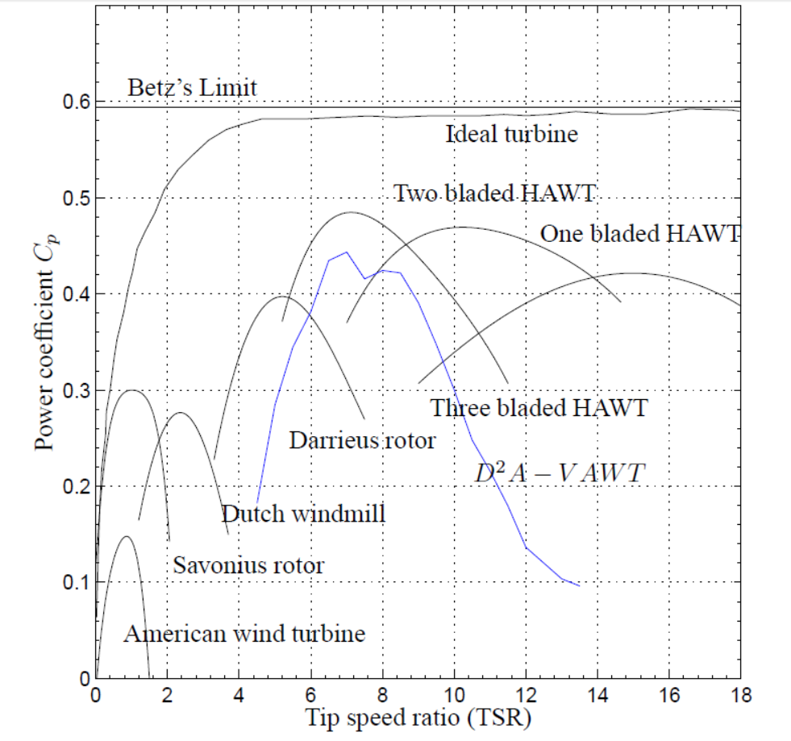

Figure 2.0.1: Variation of coefficient of performance with TSR for various wind turbines

Above figure shows the performance coefficients typical of several of the main types of wind turbines. The Cp value is plotted against the tip speed ratio which is a non-dimensional term measuring the wind speed and is defined as the ratio of speed of the blade tip to the ambient wind speed. In Figure 2.8 a comparison of aerodynamic coefficients of the common types of wind turbines from (Hau and Renouard 2006) originally from (Wilson and P.B.S.Lissaman 1974) are given. The maximumCp value measures the maximum efficiency, but most wind turbines do not operate at the optimum tip speed ratio all of the time but over a range of wind speeds and a range of tip speed ratios. Therefore, the width of the curves in Figure 2.8 is also important; a very broad curve indicates that the machine can be efficient over a wide range of wind speeds. It should be noted that if the rotor rpm is constant then the tip speed ratio is inversely proportional to the wind speed. Machines such as the Savonius and the American wind turbines have relatively low maximum Cp values and are limited to low tip speed ratios. This means that for a given wind speed, the rotors will turn relatively slowly. This, in turn, implies that the torque in the drive shafts will be higher since torque is equal to power divided by rotational speed; this is advantageous for applications such as water pumping. Figure 2.8 is a fairly accurate indication of maximum power coefficient. The peak Cp values of current HAWTs are close to 0.50 whereas the maximum Cp values that have been recorded for most VAWTs are in the range of 0.35 to 0.40. (However, Cp values of up to 0.46 were claimed for the Sandia 17-m prototype (Maydew and Klimas 1981). Thus, the HAWT technology has at least a 20% advantage in power capture by this measure. However, the peak Cp is not the only measure of overall economics. In Figure 2.8 the power coefficient of the proposed D2A − V AWT is shown by solid blue line. Transnational three bladed VAWT with single airfoil design has power coefficient of under 0.23 whereas the proposed D2A−V AWT with double-element airfoil could reach power coefficient upto 0.43 without pitch control in place.

**2.2 Types of VAWT**

There are two variants in the wind turbine. One is horizontal and the other one is vertical. For VAWT the main rotor shaft is set transverse to the wind and main components such as generator, shafts are located at the base. The arrangement facilitates the maintenance and repair due to the generator and gearbox are located close to the ground. They are categorized as drag driven type or lift driven type. The Savonius are usually drag driven type while the Darrieus and straight bladed VAWT are considered lift driven type. Other VAWT such as oval trajectory Darrieus turbine, Darrieus-Masgrowe rotor, crossflex turbine, combined Savonius and Darrieus rotor. In spite of the stated advantages of VAWTs, some researchers have claimed that Darrieus-type turbines with fixed rotor geometry and straight blades parallel to the rotation axis are not capable of self-starting.Some advantages of vertical axis wind turbines are as follows:-

* Control to track down the flow of air.
* Ability to take advantage of turbulent and gusty wind. This might accelerate the fatigue
* Problem in HAWT
* They are Omni-directional. So, we don’t need to employ different machinery such as yaw
* Easy to maintain as gearbox and generator are at the ground level. Also, gearbox of a
* VAWT takes less fatigue than HAWT
* Blades of VAWT are easy to manufacture. For example, darrieus VAWT uses constant
* Chord length which is easy to manufacture.
* Excellent potential to upscale

Need less area for VAWT wind farm than HAWT farm.

A new type of installment has been implemented which uses the installation wind turbine in the sea ,to utilize the wind power present in the sea which was used for sailing the sea. It this type of wind mill the foundation is created or it is made to float on the sea surface. Ultimately leading to catch the wind power present it the offshore wind. In offshore wind farm, VAWT has several advantages over HAWT as we mentioned earlier. Researcher are developing different kinds of floater to support VAWT. Different concepts are developed in the last decades and still different concepts are emerging

The Deep Wind project consists of a vertical axis wind turbine mounted on a floating spar buoy. The vertical axis turbine based on the concept Darrieus rotor 5 MW capacity and includes a direct drive generator with its electronic control system. Many farms of this kind are being installed in the Norway and in the English channel by the European union. Yet the major contributors are the HAWT in the offshore as well as the onshore wind power generation.

|  |  |
| --- | --- |
| Figure. 2.2: Darrieus wind turbine | Figure. 2.3: Savonius wind turbine |



Figure. 2.4: Offshore wind turbine

**2.3.1 Angle of attack**

M. Abdul Akbar , V.Mustafa has shown in there paper that by varying the angle of attack there is variation in coefficients of drag and lift as well as its ratio when Reynolds number is kept constant.[19] Authors Yanzhao Yang , Zhiping Guo , Qing Song , Yanfeng Zhang and Qing’an Li has shown in there study, the effect of blade pitch angle on the aerodynamic characteristics of the Sb-VAWT was investigated via wind tunnel experiments and CFD simulations, and then the optimal blade pitch angle was identified. The conclusions can be summarized as follows: (1) Blade pitch angle effect on pressure distribution acting on single blade surface. When the azimuth angle is in the upstream region, the pressure difference acting on the blade surface reaches maximum at the blade pitch angle of b = 6º. When the azimuth angle is in the downstream region, the pressure difference acting on the blade surface reaches maximum at the blade pitch angle of b = 8º. (2) Blade pitch angle effect on torque coefficient acting on single blade. When the azimuth angle is around q = 100º, the torque coefficient acting on single blade reaches maximum at the pitch angle of b = 6º. When the azimuth angle is around q = 260º, the maximum torque coefficient is obtained at the blade pitch angle of b = 8º. (3) Blade pitch angle effect on power coefficient. At the optimal tip speed ratio of l = 2.19, the power coefficient is the largest when the blade pitch angle is b = 6º. Compared to HAWT, the blade pitch angle has no significant effect on the power coefficient.[13,14] Raciti Castelli , the vertical axis wind turbine has an inherently non-stationary aerodynamic behaviour, mainly due to the continuous variation of the blade angle of attack during the rotation of the machine: this peculiarity involves the continuous variation both of the relative velocity with respect to the blade profile and - although to a lesser extent - of the corresponding Reynolds number.[11]

**2.3.2 Parameters**

Deglaire et al. , who did a numerical study to evaluate the forces on a rotating blade of the straight type VAWT, mentioned that a blade profile is one of the key factors to affect the performance of a wind turbine .[15] A study illustrate that the performance of a turbine is enhanced with increasing the Reynolds number, and decreasing the number of blade. So Reynolds number directly affects the performance of wind turbine .Javier Castillo has shown that a three-bladed design is more efficient than a four-bladed rotor; a low solidity wind turbine may present self-starting problems as rotor efficiency is poor at low tip speed ratios. There is an optimum turbine rotational speed for each ambient wind speed at which the maximum efficiency is achieved. The energy production of a fixed pitch wind turbine can be improved adjusting the rated air speed to the place of installation average wind conditions in order to reach its maximum efficiency. Larger radius turbines are more efficient than small turbines at same rotational speed as the tangential airspeed increase leads to smaller angles of attack, bigger Reynolds numbers and thus bigger blade lift coefficients.[18]

### 2.4 Aero foil NACA series and S1210 effect on output of turbine-

### The choice of an airfoil is of paramount importance as “The power produced by a [VAWT] at different wind speeds is largely determined by its blade airfoil Based on the work done at Sandia National Laboratory [1].Most of the early studies of airfoils for VAWTs were using symmetric airfoils such as the NACA 00-series. Symmetric airfoils were used in the Sandia 34 m VAWTs that were used in the 1970s through 1990s. These airfoils can produce power; however, they suffer from the self-starting problem mentioned previously[2].More recent research has considered cambered airfoils for VAWTs. A cambered airfoil, while increasing the drag a bit, has the potential to allow for self-starting of the VAWT in an entirely passive way [3].

VAWT blades have not been able to take advantage of the same research as the VAWT blades do not exist in the same environment as either wings or propellers. While there are many airfoils from which to choose as a basis for a VAWT blade, the aerodynamics of a VAWT are much more dynamic than a HAWT and require substantially more refinement to maximize performance. In particular, a VAWT experiences flow with a wide range of angle of attack during each rotation[3]

2.5 Design criteria

From the flow conditions in which the VAWT turbine operates, described in the previous section, certain airfoil design parameters can be established. Optimum values for these parameters may be conflicting and compromises should be made. The design is made using the NACA 0018 airfoil as reference. In chapter 5 more information about the design of the new airfoil is given.

The parameters of interest are:

* Designed to perform well at Reynolds numbers between 150,000 and 700,000
* Low zero drag coefficient
* Increased width of the drag bucket to maintain performance over a larger range of α
* Increased thickness to improve structural strength
* Smooth stall characteristics to reduce noise
* Large separation bubbles which extend over the trailing edge are a source of noise Also deep stall characteristics are important with regard to airfoil design:
* Postpone deep stall to a larger angle of attack; a thicker airfoil will in general also have deep stall at a higher angle of attack
* The deep stall hysteresis loop should be as small as possible. Thicker airfoils have generally a larger drop in lift at deep stall
* The lift coefficient drop at deep stall should be as small as possible Furthermore the use of cambered airfoils instead of symmetrical ones is investigated.

The lift force generated by the blade has a tangential component in the direction of rotation. If the contribution of the drag force is smaller than that of the lift force, the blade contributes positive torque which drives a load connected with the central rotating shaft. The orbital position of the blade is called azimuth (θ) and both relative flow velocity and the local angle of attack (α) vary with θ. The amplitude of this variation is related to a non-dimensional parameter known as tip speed ratio (λ = (Rω)/Va)) [4].

**2.6 Self-starting problem of straight blade (S.B.)VAWT**

It is commonly believed that small-capacity SB-VAWT are inherently unable to self-start properly. This notion is true for older designs which were constructed by utilizing old symmetric NACA airfoils. the inability of Darrieus type VAWT to self-start is due to a band of tip speed ratios below operating condition for which the net amount of energy collected by each blade in each revolution is negative. To achieve self-starting, SB-VAWT must be altered so that a net positive amount of torque is produced at all tip speed ratios up to the operating point. As shown in Figure 3, at low values of λ, the blade of SBVAWT encounter a wide range of α and thus fluctuates between stalled and unstalled conditions. At low λ, the blade is stalled at almost all azimuth angles. As a result, most fixed pitch Darrieus turbines do not self-start reliably and it is only at higher values of λ, above about 3, that the blades remain ‘unstalled’ and the turbine can achieve high efficiency. The problem of self-starting can be alleviated by (i) using high-lift low-drag special purpose airfoil; and (ii) by incorporating a Savonius rotor or torque [5] Self-starting problems can be overcome electrically if the SB-VAWT is coupled with a synchronous alternator or a DC generator which can function as a motor and can be used to drive the turbine up to operating speed. Although motor starting is used in grid-connected wind turbines and could be done with smaller capacity wind turbines, it is not a common practice.



Figure 2.5: Straight blade VAWT

A detail investigation of self-starting features of SB-VAWT was performed by Kirkewith cambered blades using profiles that exhibit superior characteristics at low Reynolds numbers and his results indicate that fixed pitch VAWTs using these blade sections should self start reliably. For a given VAWT, the airfoil will have to be specifically tailored to ensure optimal performance. A detail investigation of self-starting features of SB-VAWT was performed by Kirkewith cambered blades using profiles that exhibit superior characteristics at low Reynolds numbers and his results indicate that fixed pitch VAWTs using these blade sections should self-start reliably.

For a given VAWT, the airfoil will have to be specifically tailored to ensure optimal performance. However, good starting points can be found in existing literature. Many have considered the Selig S1210 airfoil as a design basis. The Selig S1210 is intended to be a high-lift, low Reynolds number airfoil. In particular, Kirke studied the Selig S1210 but added “it is likely that a profile with even better characteristics [than the S1210] for VAWTs could be designed” [3].

**2.7 Helix effect on the wings**

S.S.Suprajha , K.Vijayan in there research paper has shown that the efficiency has been improved by using helical shape for their VAWT and optimum angle of attack which they found foe there design was 4.50 at Cp of 33% there design was for darrieus wind turbine using Aluminium Alloy 1060-H18as there fabrication material using three bladed design having 1200 pitch angle of helix. [17] .Arturo Reza, Guilibaldo Tolentino & Miguel Toledo has shown in there savonius VAWT design that making the helical circular hollow shapes of wings increases the efficiency. Construction of a helical vertical axis wind turbine for electricity supply[18]

**2.8 Mass of rotor**

In general the turbine rotor mass is of particular concern as a design driver. The rotor mass is defined as all of the components which rotate: principally, the rotor shaft, the struts, and the blades. As the turbine rotor becomes more massive, all connecting systems must be upgraded, including the rotor shaft, the tower, and the foundation. Thus a lighter turbine mass is generally desired. Furthermore the lighter the blades and rotor are, the smaller the rotational moment of inertia of the VAWT rotor. This, in turn, allows the turbine to spin up and subsequently respond to wind gusts more quickly. Both of these features will then lead to greater power production and a higher capacity factor for the wind turbine. The primary concern for a lighter turbine is one of structural or dynamic loads. Heavier, more massive blades are generally stronger and dampen vibrations better. Thus a trade-off must be made between a turbine that will ensure a safe, long operation, and one that is lighter and more responsive. [6]

**2.9 Number of blades**

As pointed out by Howell et al[8], solidity is one of the main parameters dictating the rotational velocity ay which the turbine reaches its maximum performance coefficient. With experimental studies he compared the behavior of a two and three bladed VAWT, and demonstrated that the two bladed generates an higher power than the three bladed and the peak power is obtained for higher values of tip speed ratio.[13] Li S., and Li Y. made a series of numerical analysis about the effect of solidity on a straight-bladed VAWT, changing both blade chord and number of blades. They stated that the VAWT with larger solidity achieves maximum power at lower tip speed ratio. However, too large solidity will decrease the power coefficient. Furthermore, even for the same solidity, the different combination of blade number and chord affects the power [9].As can be seen, with the increase of blade number the torque coefficient peak becomes lower and the frequency of the oscillations in the torque is increased. That happens because in a complete 360° rotation of the rotor, the number of periods become higher. The average, maximum and minimum value of Ct for the three analyzed rotors is stated by them, for the tip speed ratio of maximum power coefficient. It can be seen that if the blade number is increased, the oscillations of Ct are reduced, while its average value remain almost constant.[8]

Table 2.1 : Variation of coefficient of torque with No. blades

|  |  |  |  |
| --- | --- | --- | --- |
| **No table of figures entries found.** | **Ct,avg** | **Ct,max** | **Ct,min** |
| N = 3 | 0.16 | 0.25 | 0.07 |
| N = 4 | 0.16 | 0.2 | 0.12 |
| N = 5 | 0.17 | 0.2 | 0.14 |

Numerical analyses were performed in order to understand the effect of blade number on the behavior of a straight-bladed vertical-axis wind turbine. The numerically predicted peak of power coefficient lowered with the increase of rotor solidity, while it moved to lower tip speed ratio. In fact, larger numbers of blades allowed to reach the maximum power coefficient for lower angular velocities, but were penalized as far as efficiency is concerned [8]

.

**2.10 Rapid Prototyping**

The primary and historic application of 3D printing technology for wind turbines has been through rapid prototyping – where anmodel of a part for industrial manufacture is produced through the 3D printing process such that engineers and designers can test certain component properties within a controlled environment before releasing a design into full production. Typically scale models of larger components are printed. 3DP rapid prototyping has been utilized in the sustainability technology sector to produce aerodynamic research models [7]. Hydro turbine prototypes and recently micro-scale wind turbines . In each of these cases the printed parts were prototypes simulating the construction and shape of the manufacture-able part in different materials and construction means [14]. R. Carriveau, S.-K.D. Ting has studied and shown ABS (Acrylonitrile Butadiene Styrene) and PLA (Polylactic Acid) plastics are most common within the Riprap 3D printing industry and most extruders are capable of easily extruding these materials reliably. The low bed temperature requirements of the PLA material presents a great advantage as it can be printed without a heated print bed. Printers without heated print beds are significantly less expensive than heated ones. Due to the low cost, high availability, and basic printer requirements, ABS and PLA materials were selected for use with the 3D printed wind turbine developed herein. High temperature materials Polycarbonate and Nylon may prove more attractive in the future as common 3D printers advance to include the controls required to print these materials [14] .R. Carriveau, S.-K.D. Ting in there research paper shown that the potential for rapid manufacture-able wind turbines has been evaluated in context of project objectives and design considerations. Concepts presented in existing literature regarding 3D printing have significant potential for application on small scale wind turbine technology. A new rapid-manufacture-able design has been presented based on the Venetia VAWT of previous study which is easily scalable in both width and height dimensions. Print analysis has shown that components printed at 0.04 mm and a sparse fill percentage ranging 10%–40% are practical from a print time perspective. Preliminary study of K. Bassett and R. Carriveau has shown there is great potential for 3D printing small wind turbines but research is required to further qualify and quantify this potential. The developed design serves as an effective platform for further design optimization and is particularly useful as an education and experimental tool as fundamental aspects of VAWT performance can be investigated easily due to the scale-able and modular design. Components for small wind turbines can effectively be rapidly manufactured with low-cost Riprap based 3D printers. Experimental analysis is required to investigate the developed turbine’s performance and reliability for in-field use and this is the topic of a supplementary publication.

**2.11 Diffuser and concentrator study**

## S. Zanforlin and S. letzia has conducted A2D CFD Study was came out With a convergent –divergent Wall arranged over Darrieus VAWT placed closely parallel to the ridge of a dual pitched roof can be useful to improve wind the effect of the building which increases the power by 40%-50%.with respect to the only action of the roof[19].

## 2.12 Power improvement of VAWT with an upstream Deflector

## According to Shaughnessy and Probert (1992), showed that ,with optimized configuration and position of V-shaped deflector ,a Savonious turbine could harness about 20% more power. According to Mohamed et.al(2010) optimized geometry and position of flat deflector for Are different .the performance of both turbine are similar upto 27% According to Golecha et.at (2011),the increase power coefficient was depend on the design on modified savonious turbine. According to Irabu and Roy (2007),the Savonious turbine enclosed by guide box, a rectangular box with an inlet and outlet, was effective in power output augmentation. According to Altan et.al(2008),a single stage Savonious turbine was better in terms of improvement performance than triple stage Savonious turbine with the phase shift with optimized arrangement of two deflecting flat plates that direct incoming wind advancing blades ,the power output of Savonious turbine increased more than twice form the standard turbine. Xin Jin,Yaming Wang, Wenbin Jua, Jiao Hea, Shuangyi Xiea conducted the experimental and CFD analysis and showed that the whole total efficiency can be improved significantly by optimizing the operating parameters.[22]

## 2.13 Motor and its selection

If we analyze the commercially available wind turbine generators, it is found that direct drive, grid connected generators indicate a future trend in the wind generation. The system reliability will increase by elimination of the gear boxes and the power electronic converters. Also the system efficiency will increase because the losses in the gear box and power electronic converters are eliminated. Permanent Magnet Synchronous Generator(PMSG), Field excited synchronous generator (FESG) and the Induction Generator(IG) are three candidate for such application. As permanent magnet excitation eliminates the excitation losses of a FESG hence PMSG will be more favored option. The direct drive, grid connected IG and PMSG generators are intended for fixed speed operations. When the PMSG generator is connected to the grid, the speed is determined by the grid frequency and is constant So, if the torque to the generator is increased (sudden blow of wind), the generator will produce electromagnetic force to resist an increase in speed. So, a blow of wind leads to large stresses on the wind turbine’s drive train. However IG allows a small change of speed with the change of torque going to the generator and lower stresses/tear and wear of the drive train. As the IG and the PMSG machine have similar Stator, the cost difference is mainly due to the rotor. The PM’s cost is always going to be more than that of aluminum and one can see that the cost of the induction generator is expected to be much lower than the PMSG generators for the same power rating. But PMSG generators have higher efficiency so the higher material cost may be somewhat compensated for the extra electricity generated. Also, inductive power factor of the induction generators require capacitors for power factor correction and may increases the overall cost of the IG. So, a trade-off analysis is needed for case by case basis before declaring any one machine best for an application or an Installation. The main necessity here for Wind turbine is for the WT to be able to produce power at varying wind speeds. First there was stall controlled turbines, that would stop if the wind speeds went too high or when there were wind gusts. Meaning the WT lost the ability to extract power in these conditions. A solution came in the form of active pitch control, where the blades are twisted from the hub to reduce the impact of the heavy wind on the turbine, so it is still producing power at higher wind speeds (only when it exceeds a certain wind speed it is made to stop to protect the turbine). So now the mechanical power is varying accordingly, hence we need a variable speed generator to continuously produce power. This eliminates synchronous generators and fixed speed induction generators. But by varying the AC excitation of an induction machine you could let it run at variable speed. This means using a converter with another converter at the output to grid. This converter has to be as big as the MW rating of the turbine. But this kind of a variable speed IM can still be used for WT. DFIG is the same concept extended a little further. Both the stator and rotor are supplying power to the grid and the converter does not have to be designed for the full rating but for only half the load, half the losses and problems, and half the cost. Designs without gear saves 1/3rd of the WT cost, as gear box costs a lot of money and maintenance. This can be done by making the generator bigger with better control aspects .Doubly-fed generators have both the field magnet windings and armature windings separately connected to the equipment outside the machine.  By feeding an adjustable AC power to the field windings, the magnetic field can be made to rotate, allowing variation in the generator speed.

Compared to direct-in-line-systems, DFIGs' offer several advantages:-  
1.Reduced inverter cost  
2.Reduced cost of the inverter filters and EMI filters  
3.Improved system efficiency

## 2.14 Losses in VAWT [20]

Maximum power extraction occurs at the optimal TSR, where the difference between the actual TSR (blue curve) and the line defined by a constant TSR is the lowest. This difference represents the power in the wind that is not captured by the wind turbine Frictional losses, finite wing size, and turbine design losses account for part of the uncaptured wind power, and are supplemented by the fact that a wind turbine does not operate at the optimal TSR across its operating range of wind speeds.

## 2.14 .1 Whirlpool losses Schmitz-

In the idealized derivation of the Betz Equation, the wind does not change its direction after it encounters the turbine rotor blades. In fact, it does change its direction after the encounter. This is accounted-for by a modified form of the power coefficient known as the Schmitz power coefficient CpSchmitz if the same airfoil design is used throughout the rotor blade.

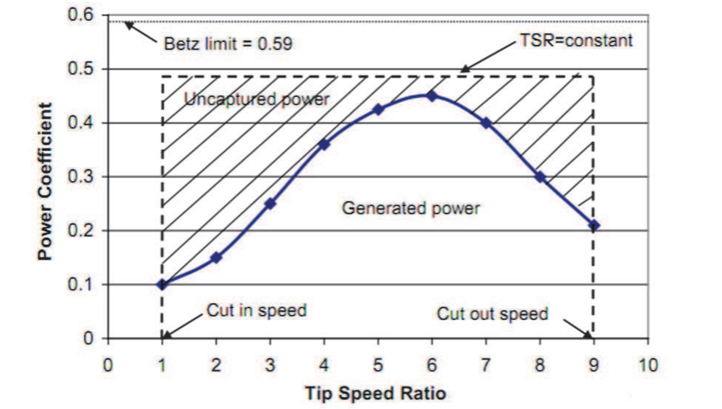

Figure. 2.6: Graph of TSR VS power coefficient

## 2.14.2 Rotor blade number losses-

## A theory developed by Schmitz and Glauert applies to wind turbines with four or less rotor blades. In a turbine with more than four blades, the air movement becomes too complex for a strict theoretical treatment and an empirical approach is adopted.

## 2.14.3 Airfoil profile losses-

## The slip or slide number s is the ratio of the uplift force coefficient of the airfoil profile used CL to the drag force coefficient CD is:

S= Cl/ Cd

Accounting for the drag force can be achieved by using the profile efficiency that is a function of the slip number s and the tip speed ratio λ as:

ή= (s-β)/s

Table 2.2Whirlpool losses Schmitz coefficient Vs Cp

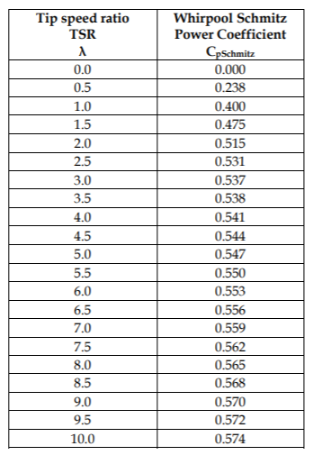

## 2.14.4 Rotor tip end losses-

At the tip of the rotor blade an air flow occurs from the lower side of the airfoil profile to the upper side. This air flow couples with the incoming air flow to the blade. The combined air flow results in a rotor tip end efficiency, ηtip end.

## 2.14.5 Gear and bearing lasses-

Friction takes of much energy and hence while transmitting the energy through the gears the efficiency gets reduced. Again supporting end causes some friction in bearings which further leads to dissipate energy causing decrease in efficiency.

## 2.14.6 Magnetic drag and electrical resistance losses in the generator or alternator –

Some eddy current dissipation and friction in motor ; magnetic resistance and electrical resistance further decreases the efficiency.

**2.15 Bearings for VAWT**

Micha Prekumar T. , Mohan T. Seralathan Siwamani carried out a simulation on the permanent magnet bearings and they found that the friction can be decrease by using rare earth magnet in cone type of bearings .They did a simulation study to increase the load carrying capacity .As we know An interest toward zero frictional losses for small wind turbine is gaining popularity because of a considerable portion of the energy is lost due to friction in the ball bearing. The concept of levitation caused by repulsion of opposite pole in the permanent magnet reduces the friction between the stator and wind turbine rotor, so that the net power output of the turbine increases. The problem associated with usage of this kind of Passive magnetic bearing is its low load carrying capacity and low stiffness [21].

# Chapter 3

# MATERIAL SELECTION

# Material for VAWT is selected depending upon the requirement of application as sometime the VAWT has to operate in cold regions or in hot regions there it has to face the wear and tear again life expectancy decides what material has to be chosen .Cost of production also decides the material which has to choosen.as the VAWT works in dynamic state so it requires the high working strength ultimately the higher tensile strength. The density plays very vital roles in selecting the material for construction of VAWT, if weight of VAWT is high then it will require the high staring torque losing self-starting ability. The materials which were best chosen for construction of blades were Alumunium7020, wood, polycarbonate, ABS (acrylo nitrile butadiene).

As here we are making which is helical in shape for savonius wind turbine and S1210 aero foil it is not accurate to make this by hands so we chose the different method like the rapid prototyping for manufacturing the prototype of our model , so that we can make any shape with the help of rapid prototyping technology. Small wind turbine technology stands to benefit greatly from this technology when considering turbines intended for disaster relief and rural electrification. With the appropriate design, wind turbines could be rapidly manufactured (printed) and assembled on-site at an as needed basis without additional tooling beyond a 3D printing machine and printing filament. We have various printing method but most suitably it depends upon the accuracy and material which we are using in rapid prototyping process. As in selective laser sintering process which has high accuracy and high cost. As here in this project we wont be able to do the fracture experiments as we are going to take only readings of power versus the velocity of air which requires the density to be same as that of actual material and the mechanical properties to be nearly same as that of PC. As the cost of PC in SLS is very high and nearby same properties can be find in ABS so we are using the ABS as our RPT material for manufacturing by FDM .The vendors nearby us were providing FDM in economic terms for ABS so we preferred the ABS by FDM and not SLS or SLA for PC.

In general the turbine rotor mass is of particular concern as a design driver. The rotor mass is defined as all of the components which rotate: principally, the rotor shaft, the struts, and the blades. As the turbine rotor becomes more massive, all connecting systems must be upgraded, including the rotor shaft, the tower, and the foundation. Thus a lighter turbine mass is general desired. Furthermore the lighter the blades and rotor are, the smaller the rotational moment of inertia of the VAWT rotor. This, in turn, allows the turbine to spin up and subsequently respond to wind gusts more quickly. Both of these features will then lead to greater power production and a higher capacity factor for the wind turbine. The primary concern for a lighter turbine is one of structural or dynamic loads. Heavier, more massive blades are generally stronger and dampen vibrations better. Thus a trade-off must be made between a turbine that will ensure a safe, long operation, and one that is lighter and more responsive.

Table 3.1: Material and their properties

|  |  |  |  |  |
| --- | --- | --- | --- | --- |
| Sr no. | material | Density(KG/m3) | Ultimate Tensile strength(MPa) | Modulus of elasticity(GPa) |
| 1 | Aluminium 7020 | 2770 | 350 | 70.0 |
| 2 | Polycarbonate | 1230 | 70 | 2.00 |
| 3 | ABS | 1200 | 49 | 1.50 |
| 4 | wood | 700 | 7 | 10 |

# Chapter 4

# FILAMENT DEPOSITION METHOD

4.1 Introduction**-**

Fused filament fabrication (FFF), also known under the trademarked term fused deposition modeling (FDM), sometimes also called filament free form fabrication, is a [3D printing](https://en.wikipedia.org/wiki/3D_printing) process that uses a continuous filament of a [thermoplastic](https://en.wikipedia.org/wiki/Thermoplastic) material. Filament is fed from a large coil through a moving, heated printer extruder head, and is deposited on the growing work. The print head is moved under computer control to define the printed shape.

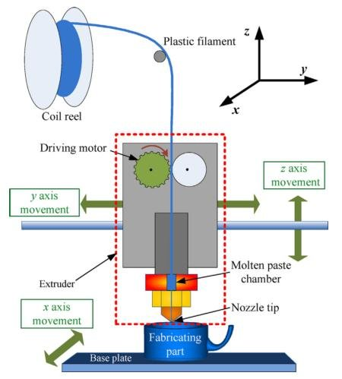

Figure. 4.1: Filament deposition method

Usually the head moves in two dimensions to deposit one horizontal plane, or layer, at a time; the work or the print head is then moved vertically by a small amount to begin a new layer. The speed of the extruder head may also be controlled to stop and start deposition and form an interrupted plane without stringing or dribbling between sections. The accuracy of machine which was used for printing was 1mm.here we exported the geometric model to standard triangular language format where it converts the surface to triangles which then be printed as surface more the triangles more the accuracy.

As shown in the below picture the STL file of savonius is created and in side figure we can see the formation of triangles.

|  |  |
| --- | --- |
|  |  |

Figure. 4.2 : Standard Triangular Language (STL) file

**5.2 List of material for FDM**

Table 4.1 : List of material for FDM

|  |  |  |  |  |  |  |  |
| --- | --- | --- | --- | --- | --- | --- | --- |
| Sr no | material | Filament($/Kg) | Weather resistance | Extrusion temperature  (oC) | Bed temperature  (oC) | Notes | Selected material |
| 1 | ABS | 30 | High | 225-230 | 105 | Heated print bed required | selected |
| 2 | PLA | 29 | Low | 175-200 | 20-70 | biodegradable |  |
| 3 | Epoxy | 85 | High | NA | NA | Polyjet type printer required |  |
| 4 | Lay wood | 40 | medium | 175-230 | 60-70 | Heated print bed required |  |
| 5 | Polycarbonate | 50 | High | 280-300 | 110-170 | Heated print bed required |  |
| 6 | Nylon | 40 | high | 238 | 60-70 | - |  |

# Chapter 5

# TO DESIGN AND ANALYSE DARRIEUS VAWT

## 5.1 Product specifications –

We are designing here darrieus type rotor for prototype fabrication.as we are designing here for the prototype and to make it self start. we have assumed to be the shape of the VAWT to be the helical or DNA type which has shown the better output characteristics than straight bladed VAWT. We had design the geometric model with the help of CREO PARAMETRIC 3.0.

For Cartesian coordinate system, enter parametric equation

in terms of t for x, y and z

For example: for a circle in x-y plane, centered at origin

and radius = 4, the parametric equations will be:

x = 4 * cos ( t * 360 )

y = 4 * sin ( t * 360 )

z = h*t Equation of helix which we are choosing is

x = -150* cos ( t * 360*0.5 )

z = 150* sin ( t * 360*0.5 )

y = 400*t

t= parametric parameter

the dimensions of the rotor which we are designing for are of

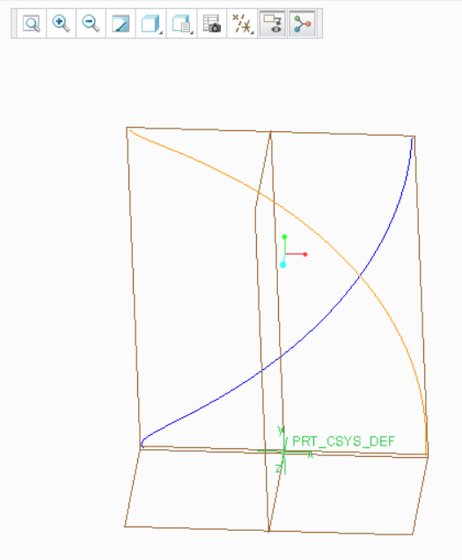

Figure. 5.1 : Helix Equation and its visualization

D=300mm

Height=400mm

Material=ABS

Power=5 W

Speed=60RPM

Size of Airfoil=50mm

Pitch of helix=800 mm

Undisturbed Wind Speed= 5m/s

Cut in, rated and cut out wind speed [m/s] =25 m/s

Density of air=1.2 kg/m3

Viscosity of air=1.67e-05 N.s/m2

No. of air foil= 2

Air foil type = S1210

Reynold number = 167000

Estimated Coefficient of Performance= 35%

Mass of whole darrieus= 0.157 Kg

Normal Angle of attack=60

To calculate the swept area( A1)=.42*.30=0.126 m2

Area of 2 similar triangle (A2)=0.42*0.140=0.0588m2

Approx. swept area=A1-A2=0.0672m2

Max Kinetic energy that can be captured=.5*125*1.2*0.0672=5W

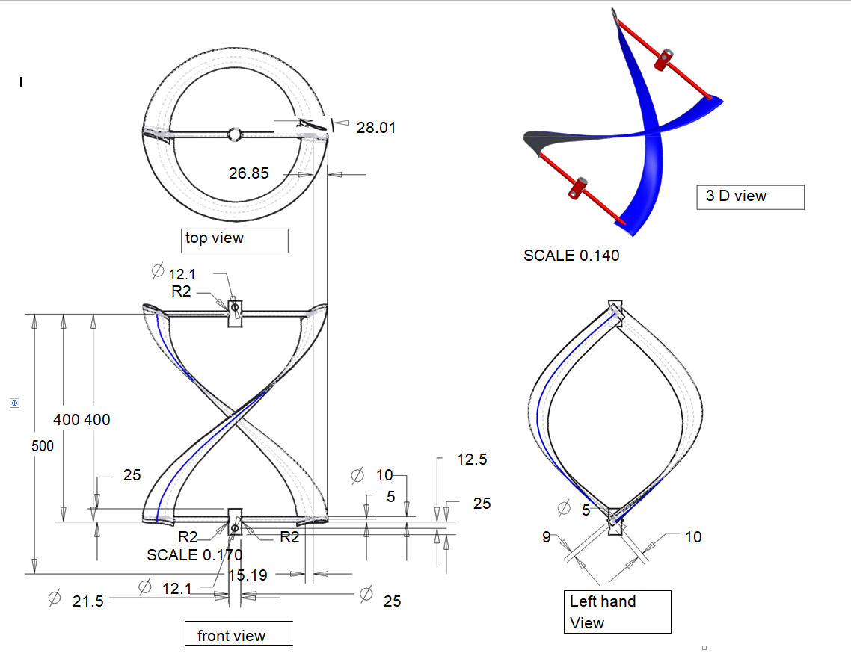

Figure. 5.2: Darrieus geometric model detailing

5**.2 Selection of mechanism**

In mechanism we have to choose the type of air foil and the load and stress supporting mechanism ,in this thesis we are using simple tubes for supporting.

## 5.2.1 Selection and plot of air foil S1210

## S1210 wing has high lift coefficients as compared to NACA series . We know that to produce the positive torque the lift coefficient must be greater that the drag coefficient. The s1210 and NACA 2412 is plotted as shown below:

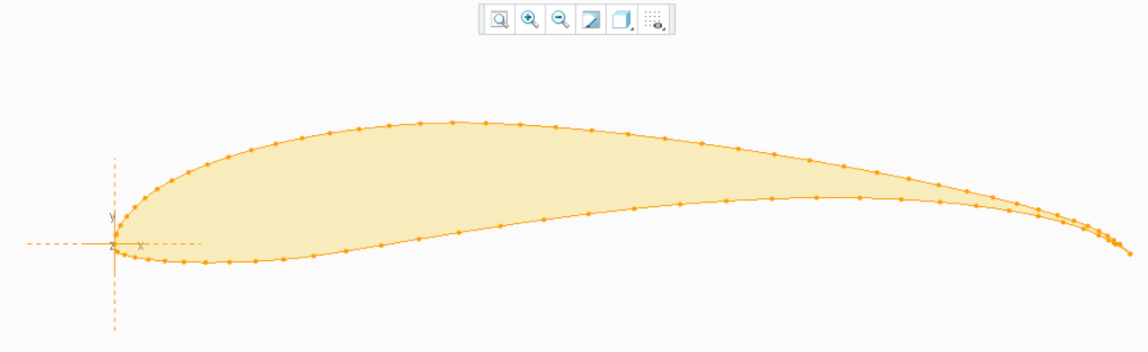

Figure. 5.3 :Aero foil S1210

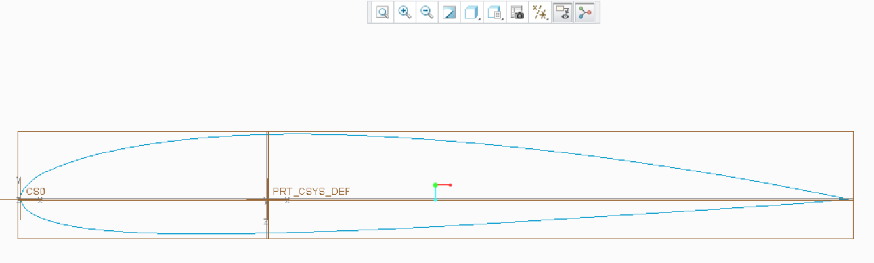

Figure. 5.4: Aero foil NACA2412

It is shown experimentally that the lift coefficient of S1210 is much higher as compared to the NACA2412 and hence we choose the S1210 as our design air foil. As we are working under very low velocity which produces very low Reynolds number which can be calculated as The Reynolds number is a commonly used nondimensional parameter in fluid mechanics, which describes the ratio of inertial forces to viscous forces. In the context of VAWTs, the Reynolds number is defined using the kinematic viscosity of the air, the freestream velocity of the wind, and the chord length of the blade as follows:

Re= c * UN/ ν

c =50mm

UN =5 m/s

ν =1.67e-5 N.s/m

Re=15000

For

c =50mm

UN =25 m/s

ν =1.67e-5 N.s/m

Re=74850.29

Here we plot the values of Cl and Cd for Reynolds number lying between 50000-200000 for S1210 aero foil and there graphs are plotted as shown in following pages. Where c is the chord length, UN is the free stream velocity of the wind, and ν is the kinematic viscosity. Using this definition of the Reynolds number, Kirke suggests that low Reynolds numbers contribute to difficulty in the self-starting of a VAWT. Hence larger Reynolds numbers are desired. Research shows that the Reynolds number increases the power coefficient of a given VAWT. In practice, this advice is synonymous with ensuring that (1) the wind velocity magnitude is high and (2) the blade chord, which is proportional to the blade area, is large. However, it is not clear if the fault is in the wind velocity or if there is actually a Reynolds number dependence on performance (e.g., transition to turbulence or drag buckets).

Results of Analysis in ANSYS fluent in student version 19.2 at 5 m/s for air above the NACA 2412 and S1210 are shown in next page . When studied this air foils we can conclude that at 5 m/s speed of air the pressure drop across the air foil S1210 is much greater than that of NACA airfoil and hence it will mostly utilize the Kinetic energy present in the air. That is why it will be better to choose the Airfoil S1210 than NACA 2412 for VAWT design.

From graphs we can calculate the

Cl=1.1 ; Cd=0.09

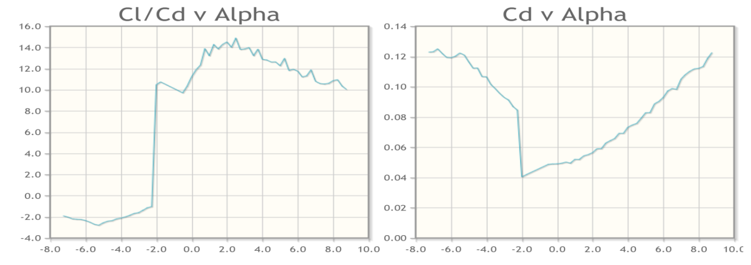

Figure. 5.5: A) Cl/Cd Vs Alpha B)Cd Vs Alpha

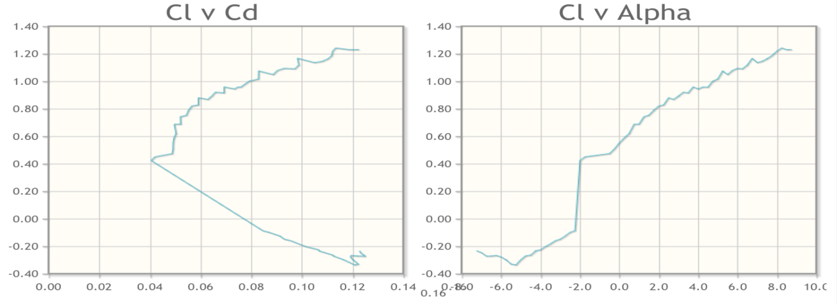

Figure. 5.6: A) CL vs CD B)CL Vs Alpha

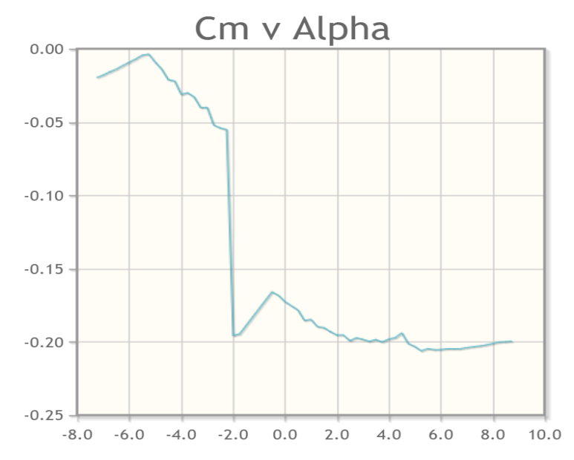

Figure. 5.7: Cm Vs Alpha

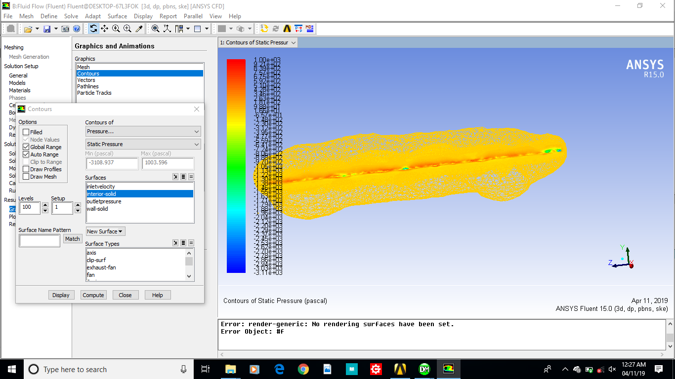

Figure 5.8: Aero foil S1210 static Pressure Drop in ANSYS for 5m/s air velocity

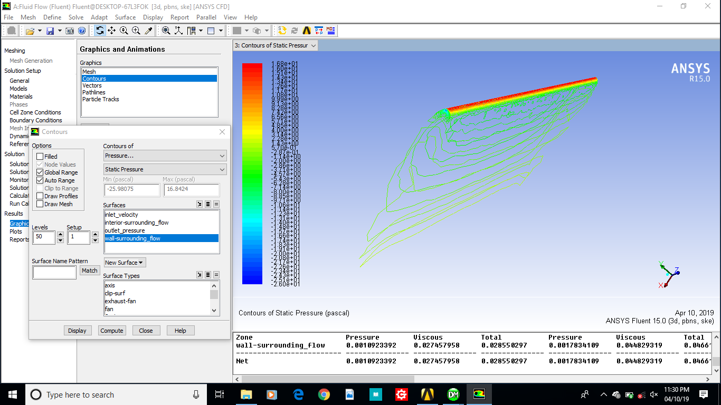

Figure 5.9 : Aero foil NACA2412 ,Static pressure drop at 5m/s

## 5.3 To calculate forces on the air foil and supporting tubes

For speed of air 5 m/s at TSR=0.2 ;ω =6.67 Rad/s

Fl=0.5* ρ *Cl*L* ω2

=1.394N

Fd=0.5*ρ*Cd*L*ω2

=0.114 N

For speed of air 25 m/s at TSR=0.2 ;ω =33.34Rad/s

Fl =34.847 N

Fd=2.8511 N

For speed of air 5 m/s at TSR=1.0 ;ω =33.34Rad/s

Fl =34.847 N

Fd=2.8511 N

For speed of air 5 m/s at TSR=1.0 ;ω =166.67 Rad/s

Fl =870.86 N

Fd=71.25 N

So maximum force for designing the turbine supporters will be the resultant of this max value of force =873.76 N

At ω =166.67 Rad/s mass=0.157Kg

Centrifugal force will be Fc

As the Fc will be carried by the 4 arms so stress will be divided into 4 arms

Fc=(mass/4)*r* ω2

=163.55N

Total tensile force will be =873.76 N+163.55N =1037.308N

Diameter of support tubes chosen to be

D0=10mm

Di=5mm

Material is ABS having the tensile strength equal to Syt=49 MPa

FOS=2

Stress carrying capacity =24.5 MPa

Induced stress=1037.308/3.142*(0.012-0.0052)=4402472.77=4.402472 MPa

Therefore the induced stress will be far lesser than the carrying capacity so the design is safe.

## 5.4 Static structural analysis and results-

1. Rotational speed 33.34 Rad/sec for centrifugal force.
2. Lift force converted to the pressure as we know the area of the lower side of the wing which came out to be the 31797 mm2 and considering the factor of safety 2.the pressure came out to be 0.05476MPa
3. Drag force converted to the pressure which came out to be 0.00474 MPa which is being applied on the upper side of the wing

The result of this static structural ANSYS comes out to be the in the safe zone which can be seen from the further results.

* 1. From fig it can be seen that the maximum stress is far below the tensile strength of the material so the structure is safe.
  2. From fig in can be interpreted that the stain is very less and it is negligibly small and hence no permanent deformation is seen at this operating conditions.

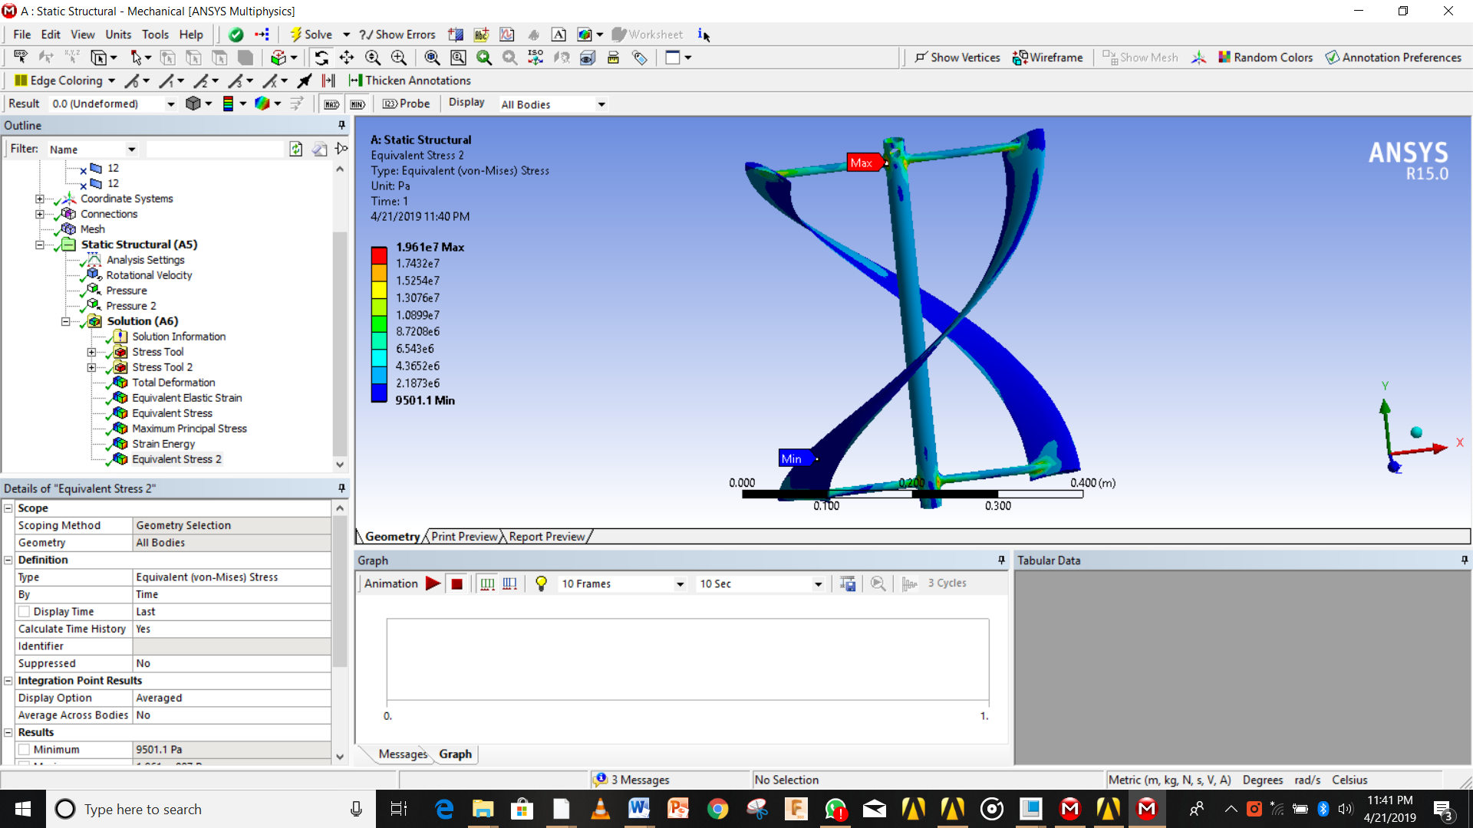

Figure 5.10: Von misses stresses visualization in Structural analysis in ANSYS

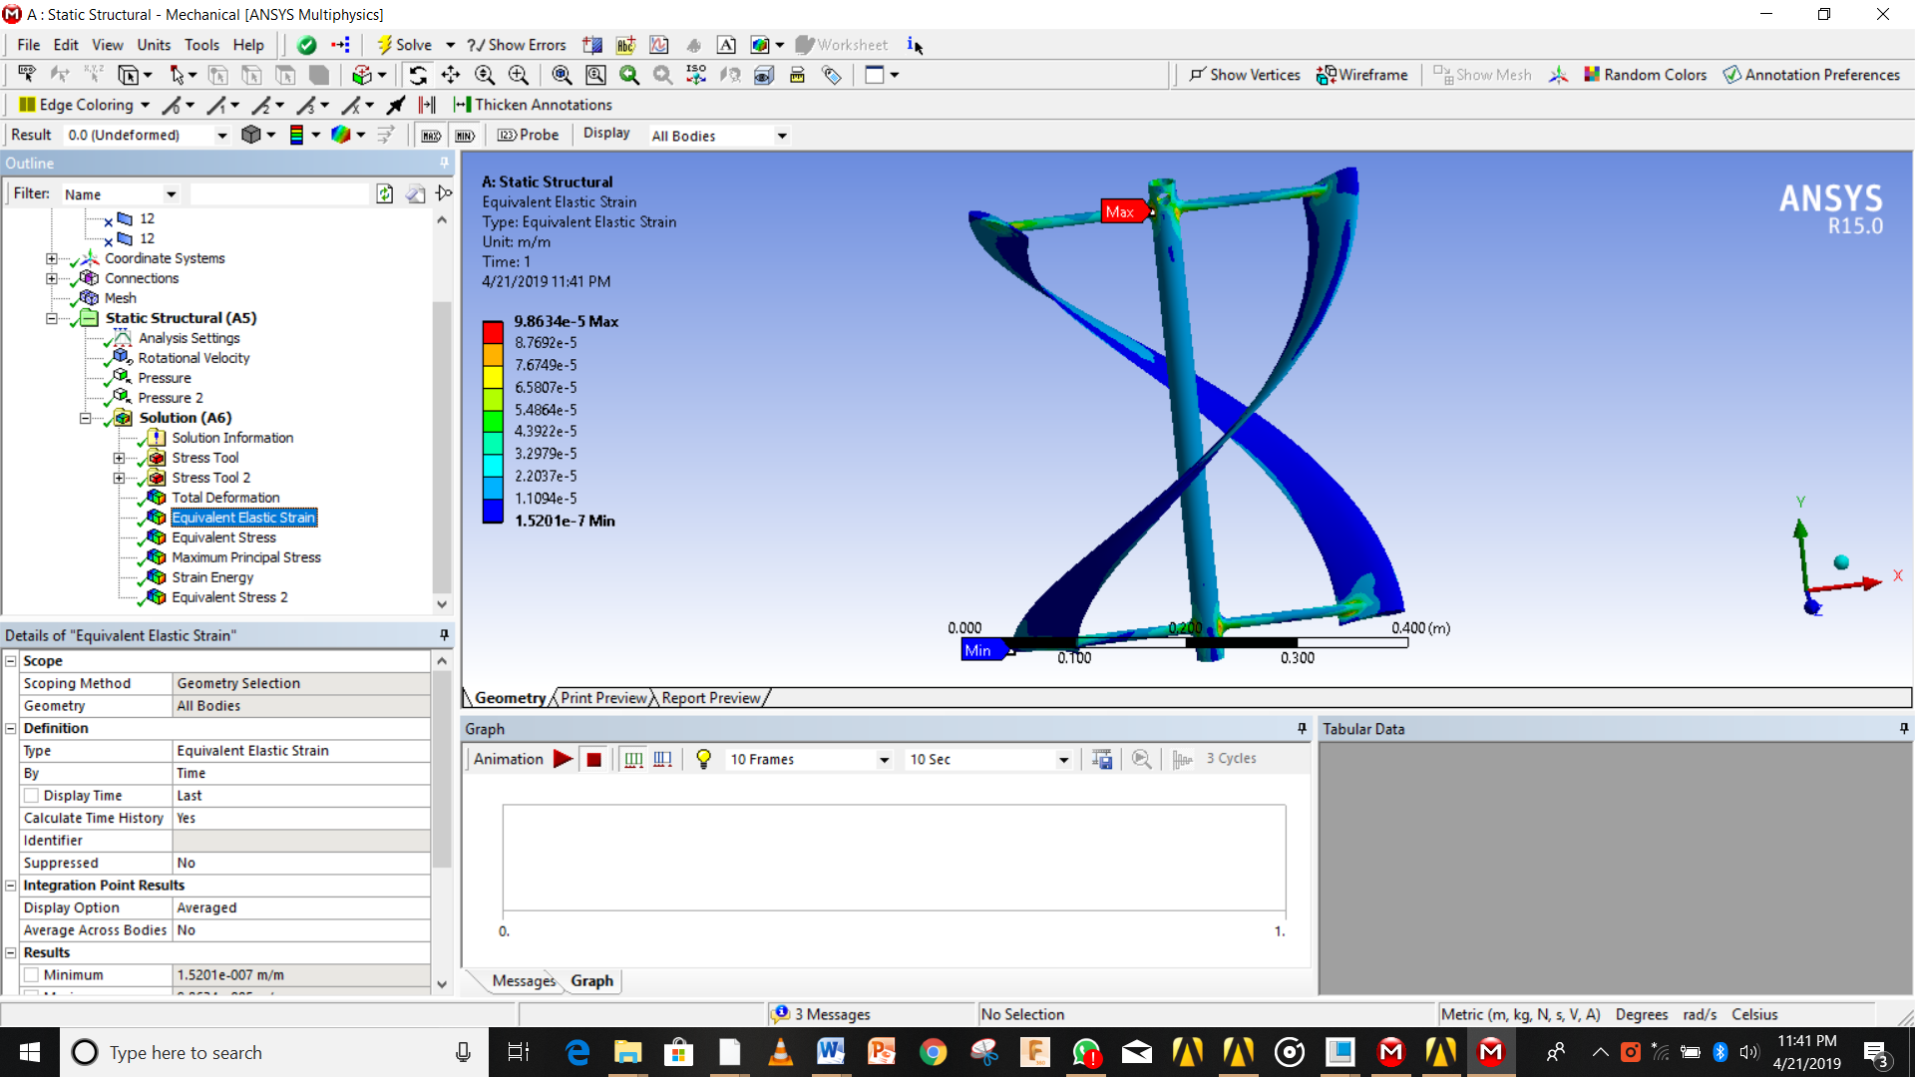

Figure 5.11: Static structural elastic strain in ANSYS

## 5.5 To analyze the model in ANSYS FLUENT -

Here we are interested in the outcome of the pressure and velocity variation along the VAWT wings which can be ultimately be inferred as the output of the power ; as more the drop in the velocity across the wings the more the pressure rise which ultimately gets converted to our lift and drag forces which creates motion of the VAWT and produces the power.

Steps and models used in the FLUENT are as follows:-

1. Import the STEP file to the geometry
2. Create the fluid domain
3. Do the meshing properly as it is the most important part of the analysis which ultimately decide accuracy and the output of the data; whenever required we had used the method and sizing for meshing the whole geometry ; and created the named selection as per requirement.
4. Update the project
5. Edit the setup
6. Choose the series and double precision
7. Choose the transient, absolute, pressure based solver
8. Chose the model to be viscous laminar and k epsilon ,RNG, Wall scale function, an create.
9. Give air density as 1.14 and absolute viscosity to be the 1.671e-5 Pa.s
10. Give boundary condition and put velocity to be 5m/s, 25m/s.
11. Create the drag and lift monitor to get the value of the lift and drag coefficients.
12. Initialize the solution
13. Give 200-1000 iterations for accuracy.
14. Run calculations.
15. Edit the results and plot the streamlines and get the required variations of variables.
16. Plot the results.

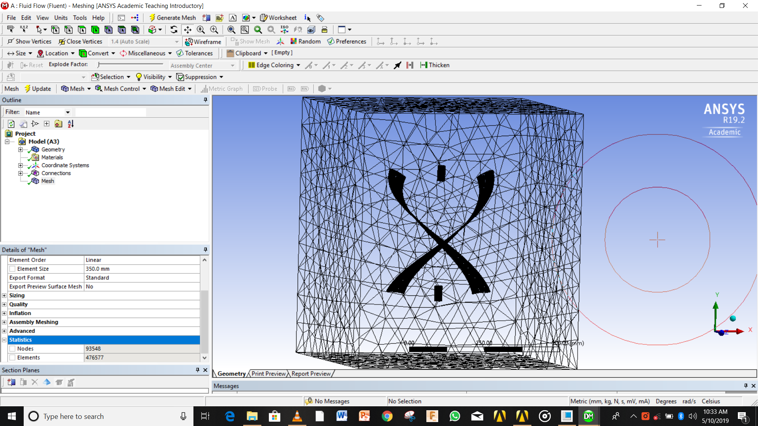

Figure 5.12: Meshing of Darrieus VAWT

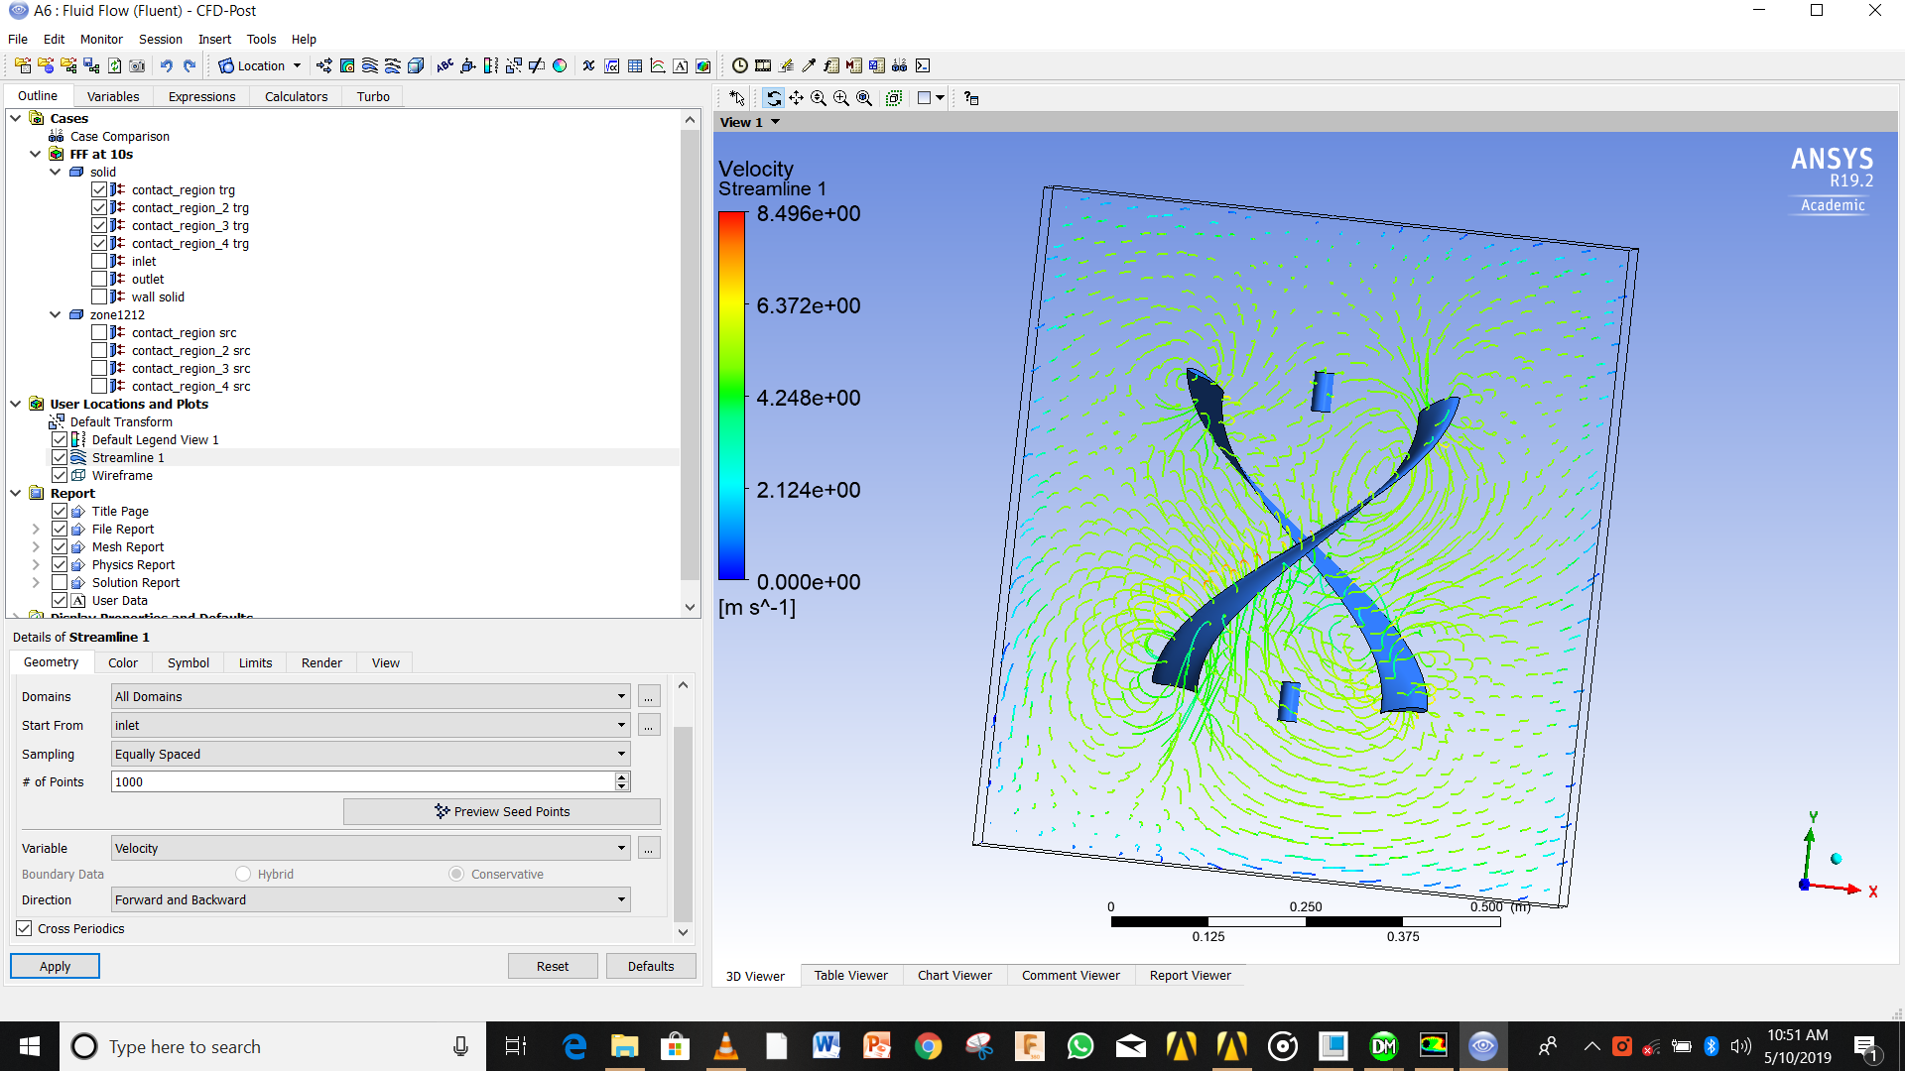

Figure 5.13: Velocity Vs Z variation

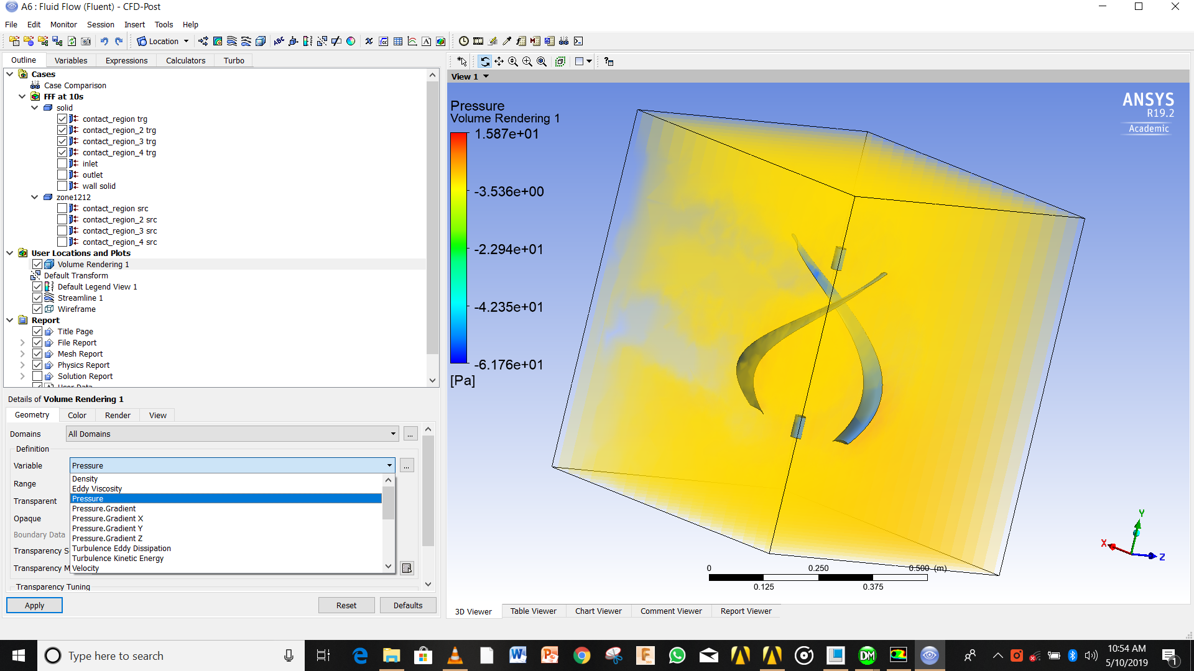

Figure 5.14: Variation of pressure with Z

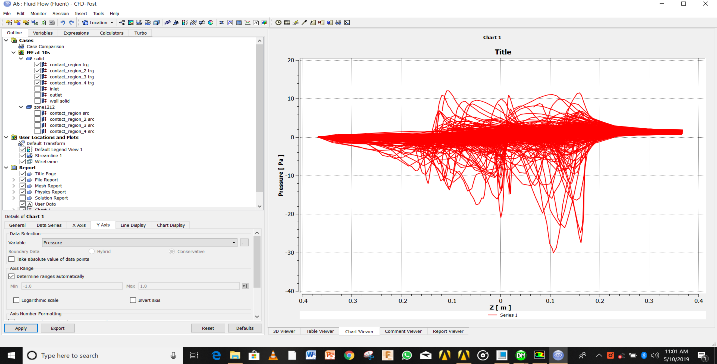

Figure 5.15 : Graph of Pressure with Z

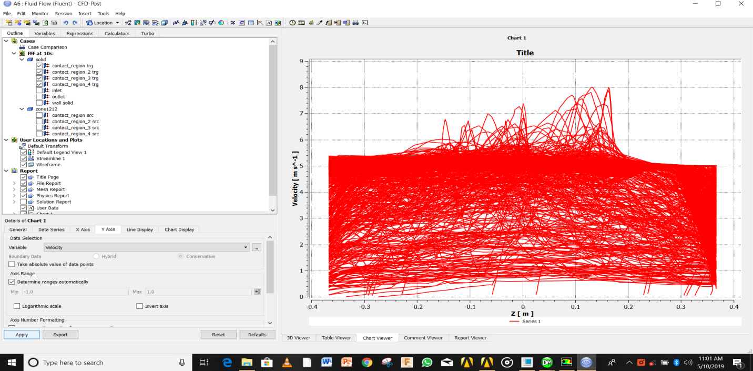

Figure 5.16 : graph of Velocity with Z

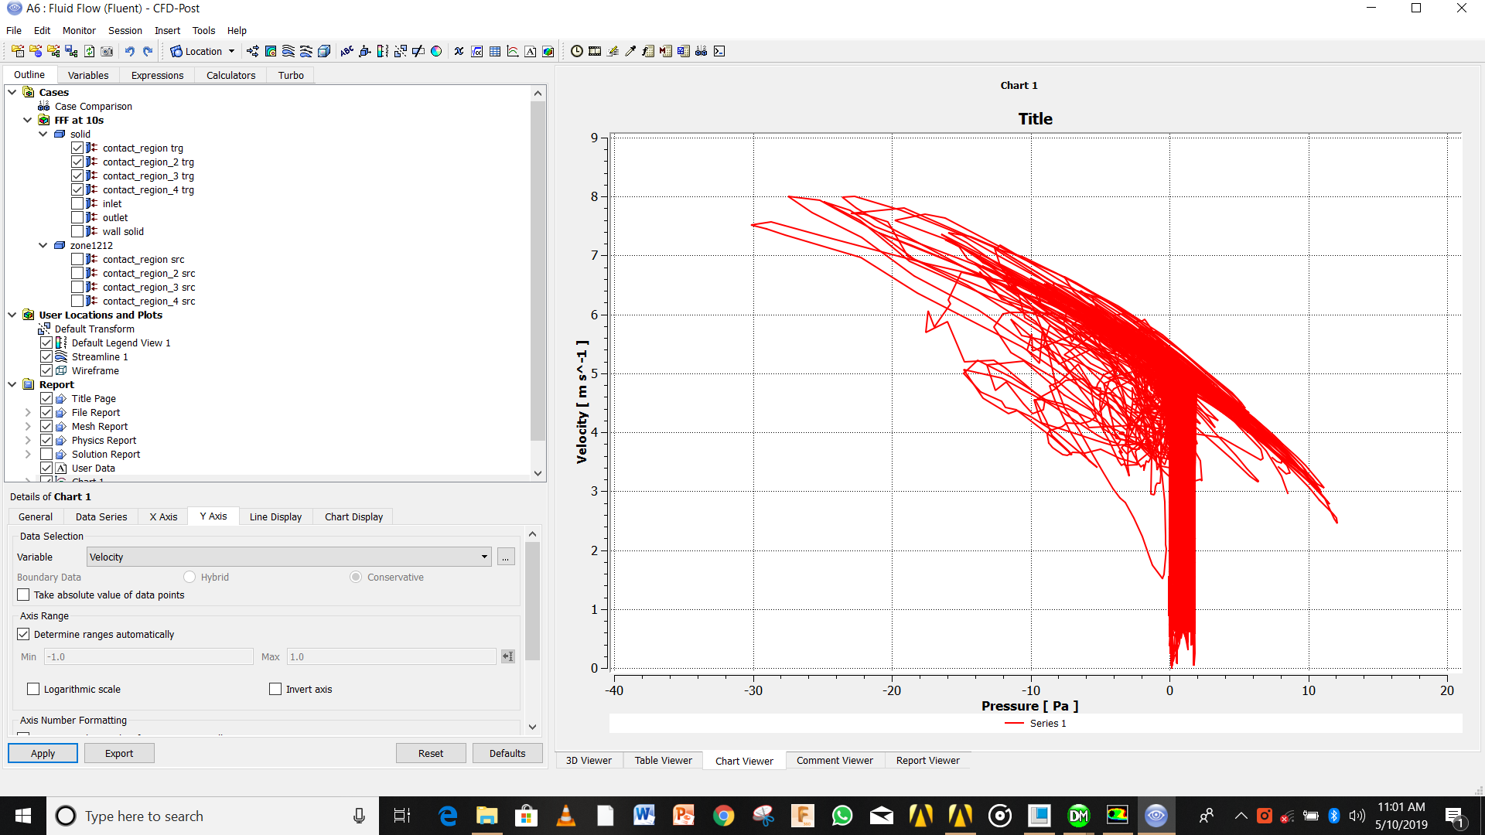

Figure 5.17: Graph of Pressure VS velocity

# Chapter 6

# TO DESIGN AND ANALYSE SAVONIUS VAWT

## 6.1 Product specifications-

We are designing here savonius type rotor for prototype fabrication. As we are designing here for the prototype and to make it self start , we have assumed to be the shape of the VAWT to be the helical or DNA type which has shown the better output characteristics than straight bladed VAWT. We had design the geometric model with the help of CREO PARAMETRIC 3.0.here we are using the elliptical cup type wing for better collection of wind. Then we have given the thickness to the blade as 1.5 mm as the material is somewhat capable of withstanding the stresses; and to decrease the mass of VAWT.

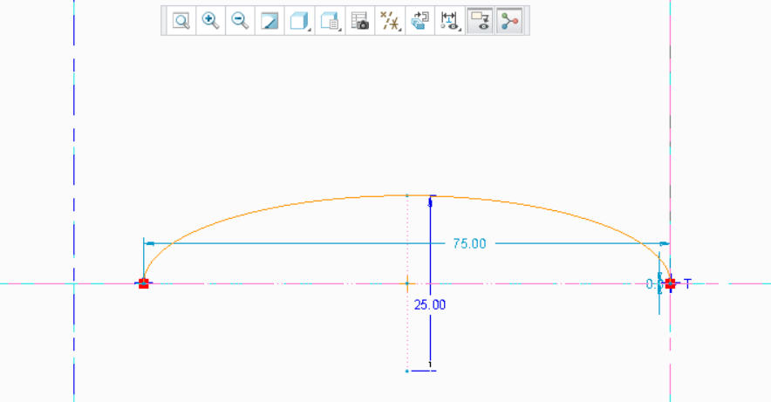

Figure 6.1 : Elliptical cup wing of Savonius VAWT

Table 6.1 : Savonius design parameters

|  |  |  |  |  |  |  |  |
| --- | --- | --- | --- | --- | --- | --- | --- |
| Sr. No. | Height(H2) mm | Rotor Diameter D2(mm) | Blade Thickness(mm) | Eccentricity e(mm) | Major diameter a (mm) | Minar diameter b (mm) | Aspect Ratio(H1/D2) |
| 1 | 300 | 170 | 1.5 | 25 | 75 | 25 | 1.77 |

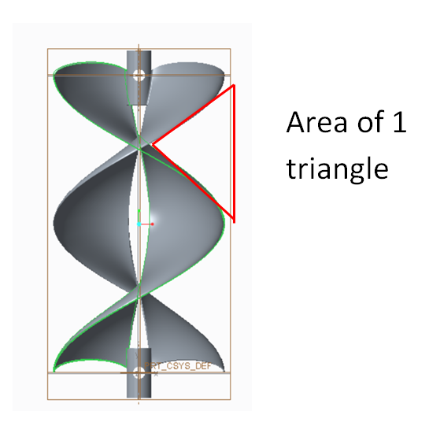

Figure 6.2 : Area which is not under consideration for Power generation

Material= ABS, UN =5 m/s

The pitch of the helix is =300 mm

Area of the rectangle (A1)=0.300*0.170=0.051m2

Area of triangles (A2)=4*.5*.15*.075=0.0225 m2

Swept area=0.0285 m2

Max pawer captured by the savonius VAWT will be

P=.5*1.14*.0285*125*.5925=1.25W

Our desired Cp= 0.2 Next page shows the savonius VAWT and its detailing,

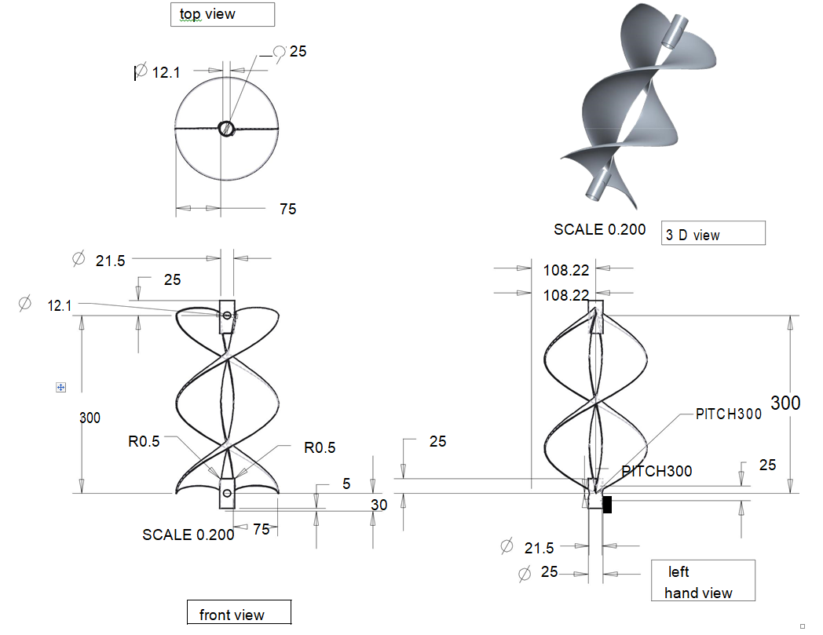

Figure 6.3 : Savonius VAWT Detailing

## 

## 6.2 To analyze the model in ANSYS FLUENT -

Here we are interested in the outcome of the pressure and velocity variation along the VAWT wings which can be ultimately be inferred as the output of the power ; as more the drop in the velocity across the wings the more the pressure rise which ultimately gets converted to our lift and drag forces which creates motion of the VAWT and produces the power.

Steps and models used in the FLUENT are as follows:-

1. Import the STEP file to the geometry
2. Create the fluid domain
3. Do the meshing properly as it is the most important part of the analysis which ultimately decide accuracy and the output of the data; whenever required we had used the method and sizing for meshing the whole geometry ; and created the named selection as per requirement.
4. Update the project
5. Edit the setup
6. Choose the series and double precision
7. Choose the transient, absolute, pressure based solver
8. Chose the model to be viscous laminar and k epsilon ,RNG, Wall scale function, an create.
9. Give air density as 1.14 and absolute viscosity to be the 1.671e-5 Pa.s
10. Give boundary condition and put velocity to be 5m/s, 25m/s.
11. Create the drag and lift monitor to get the value of the lift and drag coefficients.
12. Initialize the solution
13. Give 200-1000 iterations for accuracy.
14. Run calculations.
15. Edit the results and plot the streamlines and get the required variations of variables.
16. Plot the results.

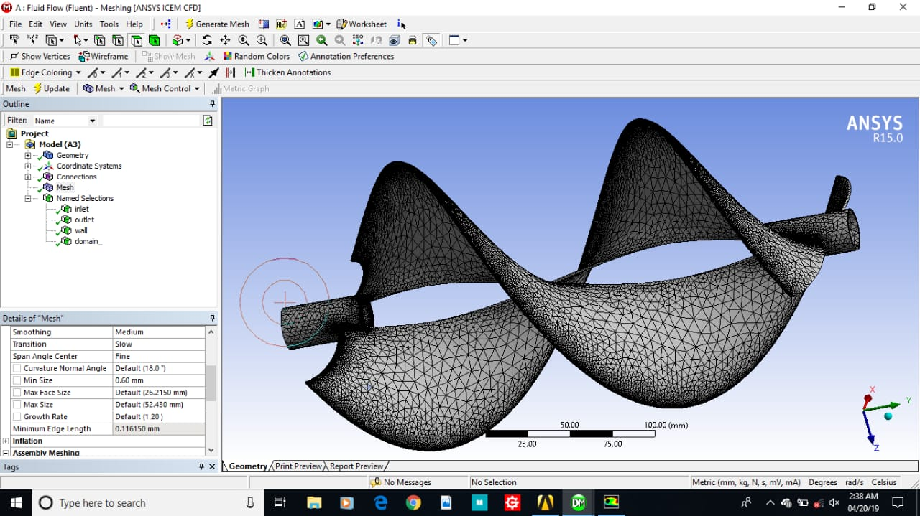

Figure 6.4: meshing of savonius VAWT in ANSYS

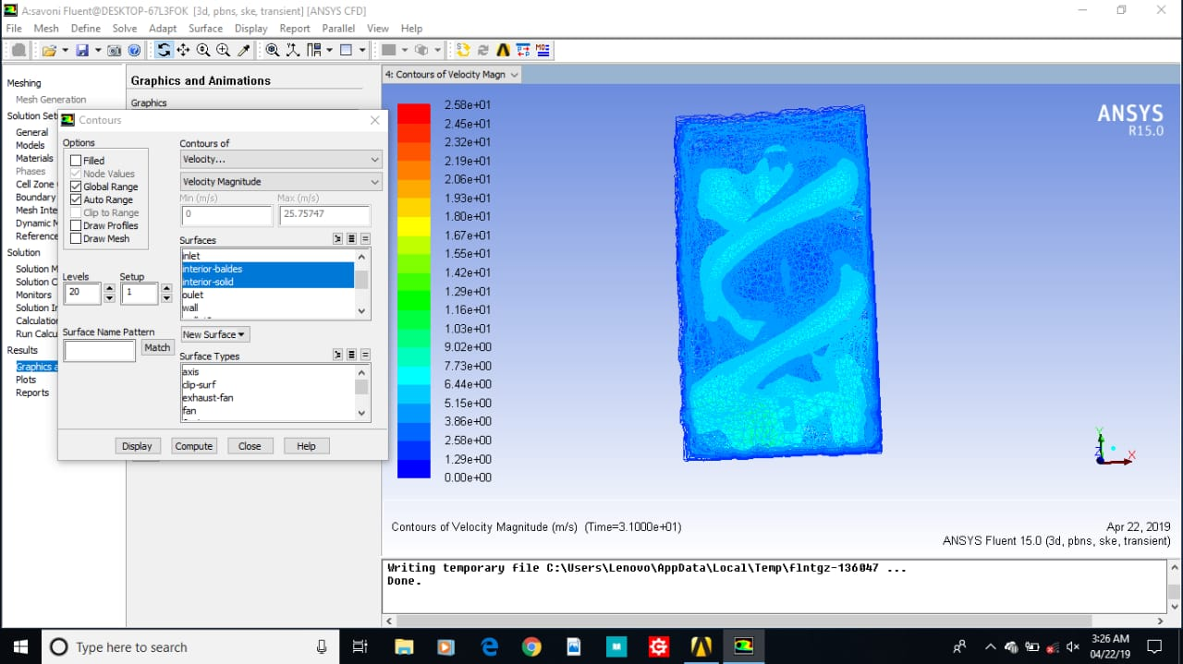

Figure 6.5 : Transient contour of velocity in ANSYS FLUENT of savonius VAWT

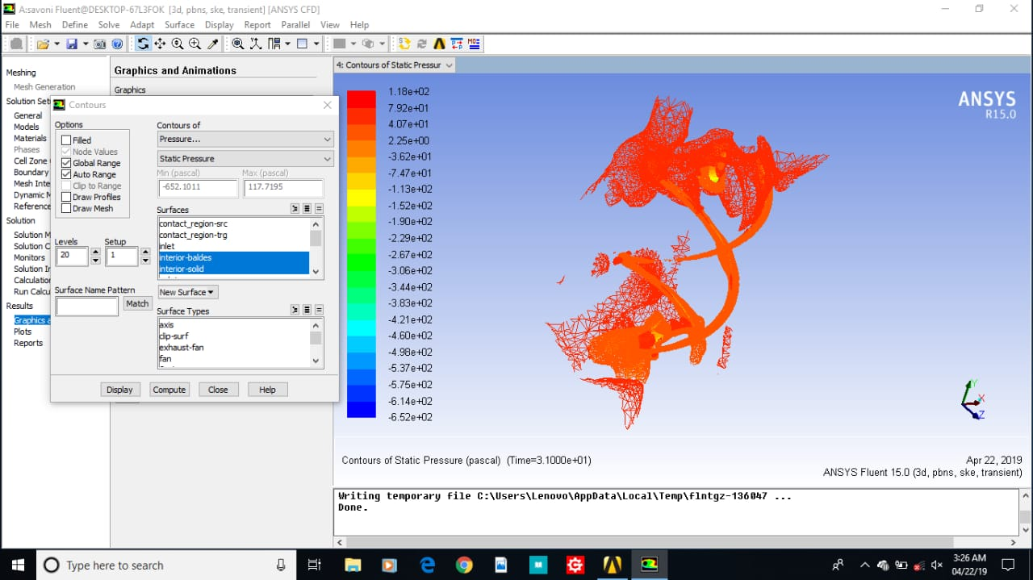

Figure 6.6: Transient contour of static pressure in ANSYS FLUENT of savonius VAWT

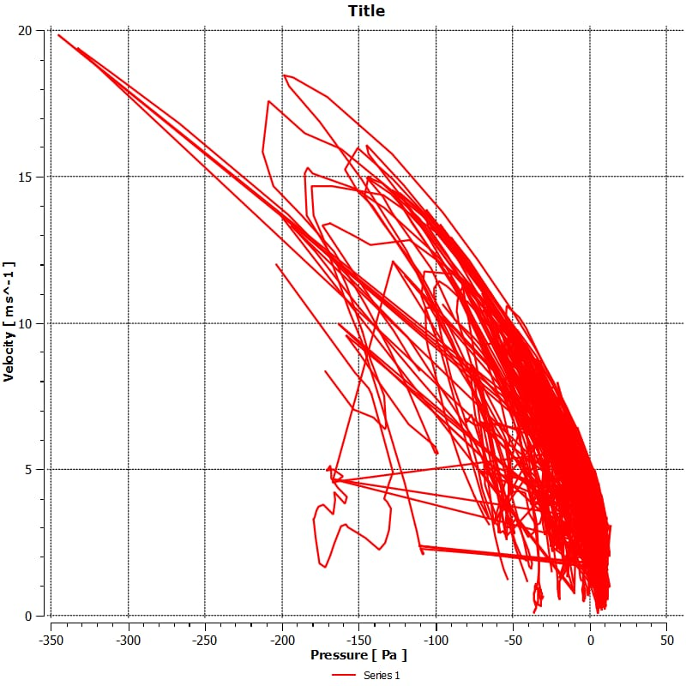

Figure 6.7 : Pressure Vs Velocity Plot for savonius In Ansys

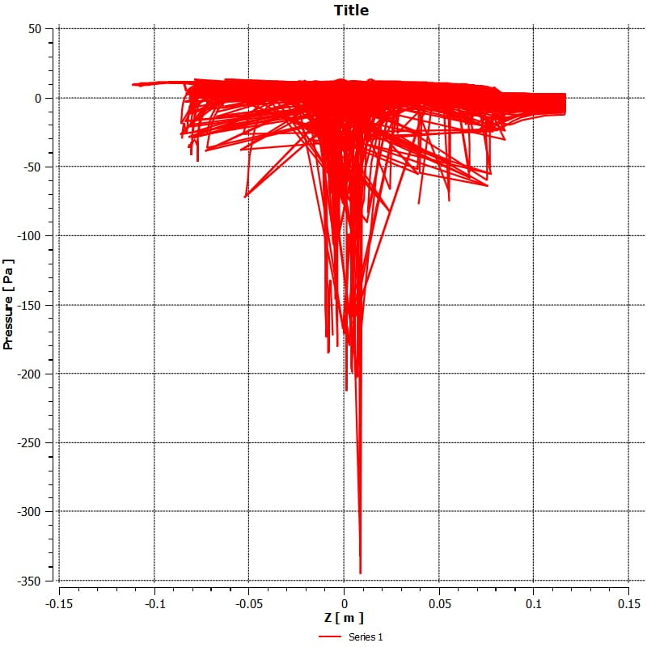

Figure 6.8 : Plot of Pressure Vs Z direction

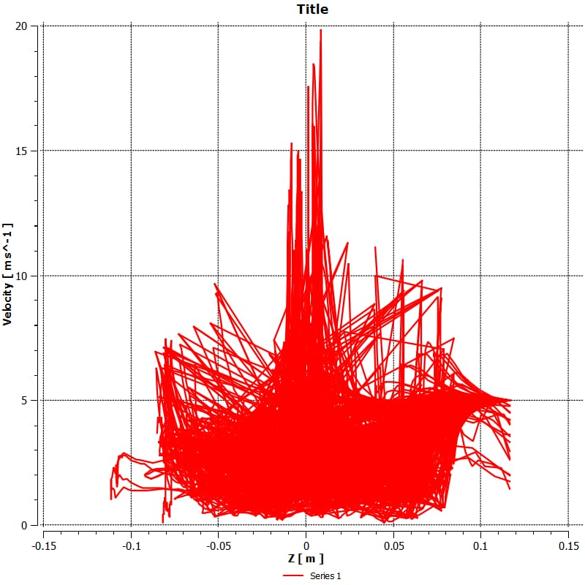

Figure 6.9 : Plot of Velocity Vs Z direction

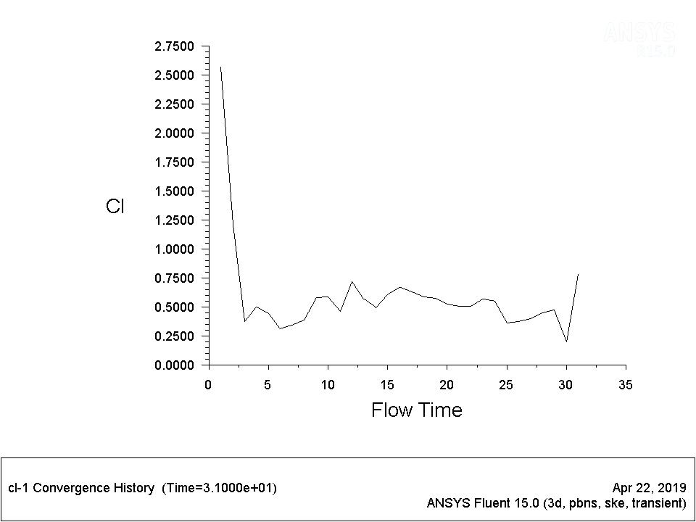

Figure 6.10: Plot of coefficient of lift for savonius

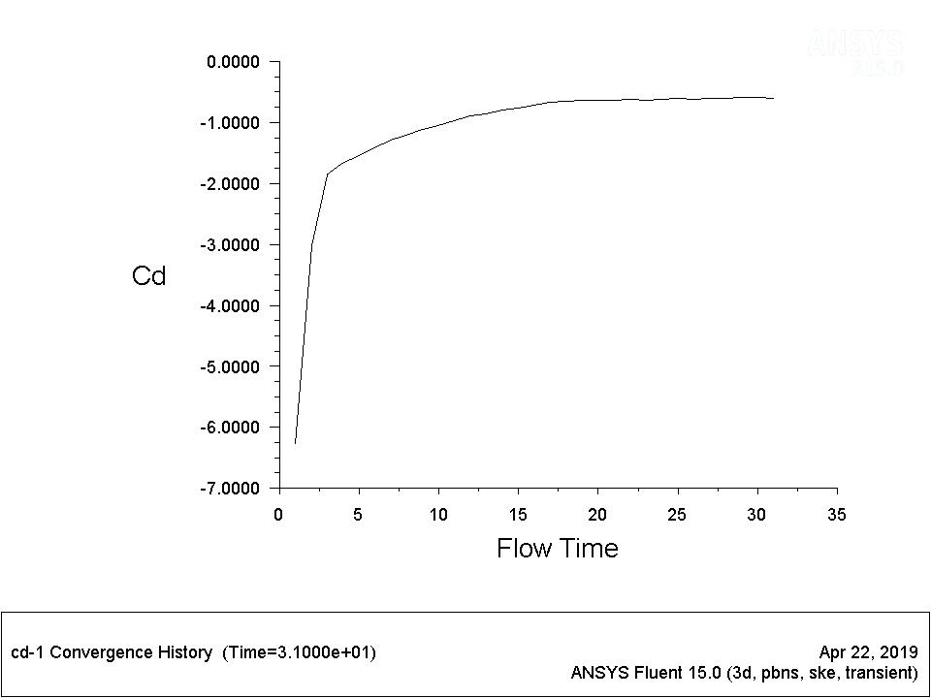

Figure 6.11: Plot of Coefficient of Drag

## 6.3 ANSYS FLUENT result Interpretation –

1. The figure shows the fine meshing and the element size used for the analysis.
2. Fig shows the variation of velocity as it increases at its tip and decreases below it and the whole continuum is shown how the maximum and minimum velocity is reached and there variation is plotted with contours over the VAWT blades.
3. In next fig we can observe the variation of the static pressure , how it increases over the tips of the VAWT, and we can observe the variation of the maximum and minimum static pressure ; as pressure decrease at some point at the tips where velocity increases in proportions and this change in pressure creates the lift and drag components of the force
4. In next figure we can observe the variation of the pressure with the velocity as the pressure increases with decrease in velocity ,there multiplication gives us the work done per unit swept area of the VAWT .
5. In next figure we can observe the variation of the static pressure over the length of the fluid domain , from here we can interpret that at the VAWT the pressure decreases very rapidly and at some points the positive pressure is also observable which leads to change the pressure again and it comes at the normal value of inlet at exit.
6. In next figure we can observe that the velocity varies over the distance spread across the VAWT and it increases over the VAWT and also comes to its normal value over the time and then reaches the inlet velocity at exit.

## 6.4 To calculate forces on the wings and supporting radius-

To calculate the force on the wings

Consider the value from the graphs Cl =0.75 ; Cd = -0.9

L=0.075 m

1. ω= 6.67 rad/sec
2. ω=33.34 Rad/sec

Fl=0.5* ρ *Cl*L* ω2

=1.426 N

Fd=0.5*ρ*Cd*L*ω2

=-1.7117 N

Fc=(mass)*r* ω2

=0.541N

At ω=33.34 Rad/sec

Fl=0.5* ρ *Cl*L* ω2

=35.639N

Fd=0.5*ρ*Cd*L*ω2

=-42.7671N

Fc=(mass)*r* ω2

=13.511N

So the total force which is being acted will go approx. 56.2781N

## 6.5 Static structural analysis and results-

1. Rotational speed 33.34 Rad/sec for centrifugal force.
2. Lift force converted to the pressure as we know the area of the lower side of the wing which came out to be the 35400 mm2 and considering the factor of safety 2.the pressure came out to be 0.001MPa
3. Drag force converted to the pressure which came out to be -0.0012 MPa which is being applied on the upper side of the wing

The result of this static structural ANSYS comes out to be the in the safe zone which can be seen from the further results.

1. From fig it can be seen that the maximum stress is far below the tensile strength of the material so the structure is safe.
2. From fig in can be interpreted that the stain is very less and it is negligibly small and hence no permanent deformation is seen at this operating conditions.

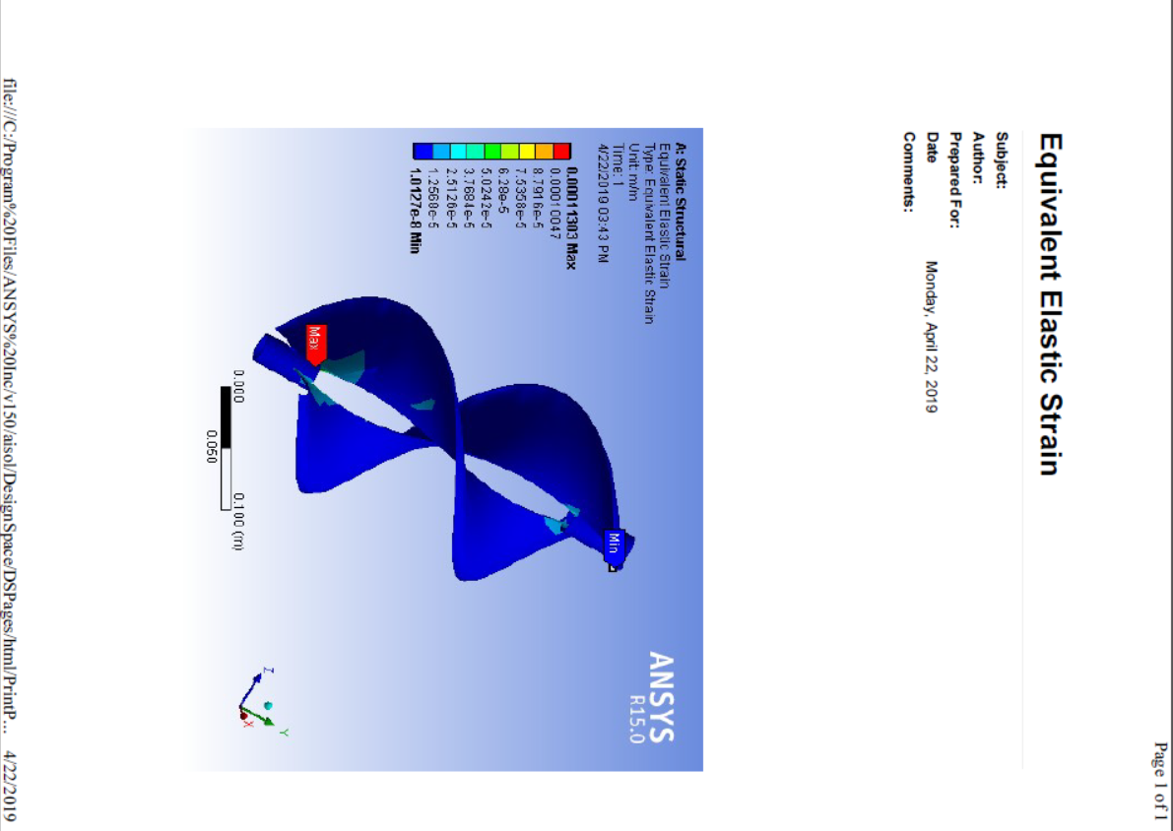

Figure 6.12: Equivalent elastic strain In ANSYS structural for savonius

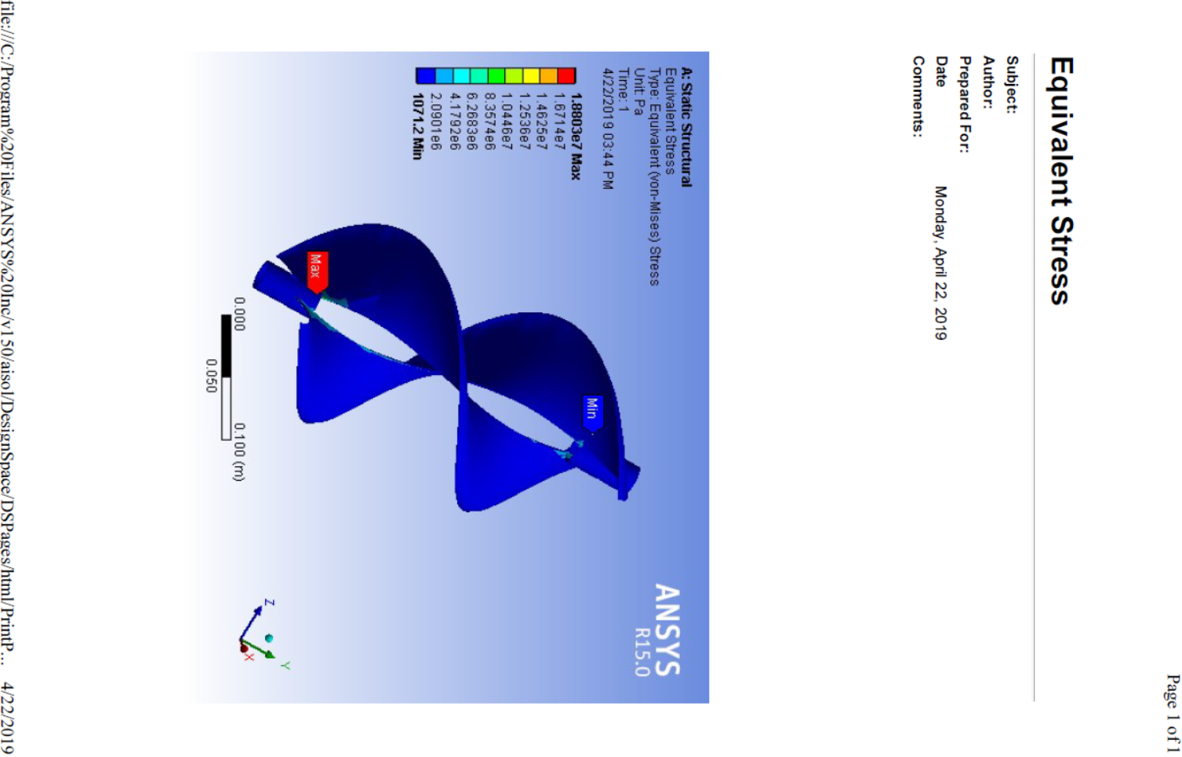

Figure 6.13 : Equivalent elastic stress In ANSYS structural for savonius VAWT

**Chapter 7**

**TO DESIGN AND ANALYSE SHAFT OF VAWT**

**7.1 Product Specification-**

Requrement of shaft are-

1. High fluctuation in speed must be sustained without any stress concentration.
2. Low hardness for assembling the shaft with the bearing , such that its fit can be jugded and changed according the requrement.
3. Availability of the size of the shaft in given size.

**7.2 Material for Shaft-**

1. The mass of the rotor decides the material that has to be chhosen foe the shaft, as we know the lower the density of the shaft higher the output will be.
2. The material should be good in commpressive strenght ultimately good in ultimate tensile strenght.
3. From above requrements we can choose the material to be the ABS which is the materual of the Prototype of wind turbine wings. But it is not economical to choose this material.
4. Hence we choose the nearby closely resembling material like PVC, but the problem has to be faced like increase in density .

**7.3 Failure Criteria-**

As the design criteria Suggests that the VAWT moves and it may Fail in tensile force as the material is brittle.

**7.4 To determine Dimensions-**

Total compressive or lift force= (Fl )Savonius+ (Fl)darrieus=35.69+ 870.86 N=906.55 N

Total Bending Force will be the net effect of centrifugal force and Drag force of all 3 element Fb=71.25 N+873.76 N-42.7671N+13.511N+0.5869 N= 916.34N

Compressive force Or lift force FF = 35.639N + 870.86 N=906.499N

Mass=64 gm

Centrifugal force by shaft(N)= Fc= (mass)*r* ω2

= 0.5869 N

As standard pipes were available in the market so, we choose the one which closely resembles our design and operating conditions ,which has following diamensions-

DO1=20 mm

DI1=16.5 mm

Max allowable deflection will be 1 mm

F=force(N)=1124.28N

I=moment of inertia (mm4) =4215.62 mm4

E=Youngs modulus of PVC (MPa) = 3300MPa

Compressive strength=9.0347 MPa < Compressive strength of the PVC

So the Shaft is safe in compression.

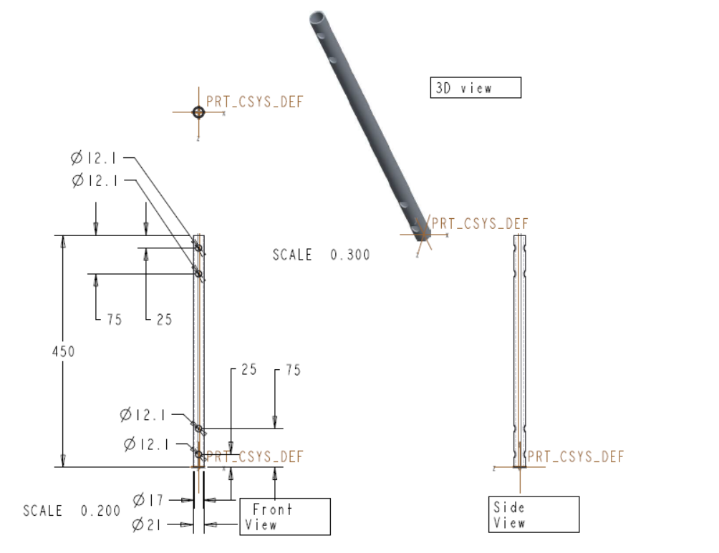

Figure 7.1 : Detailing of shaft

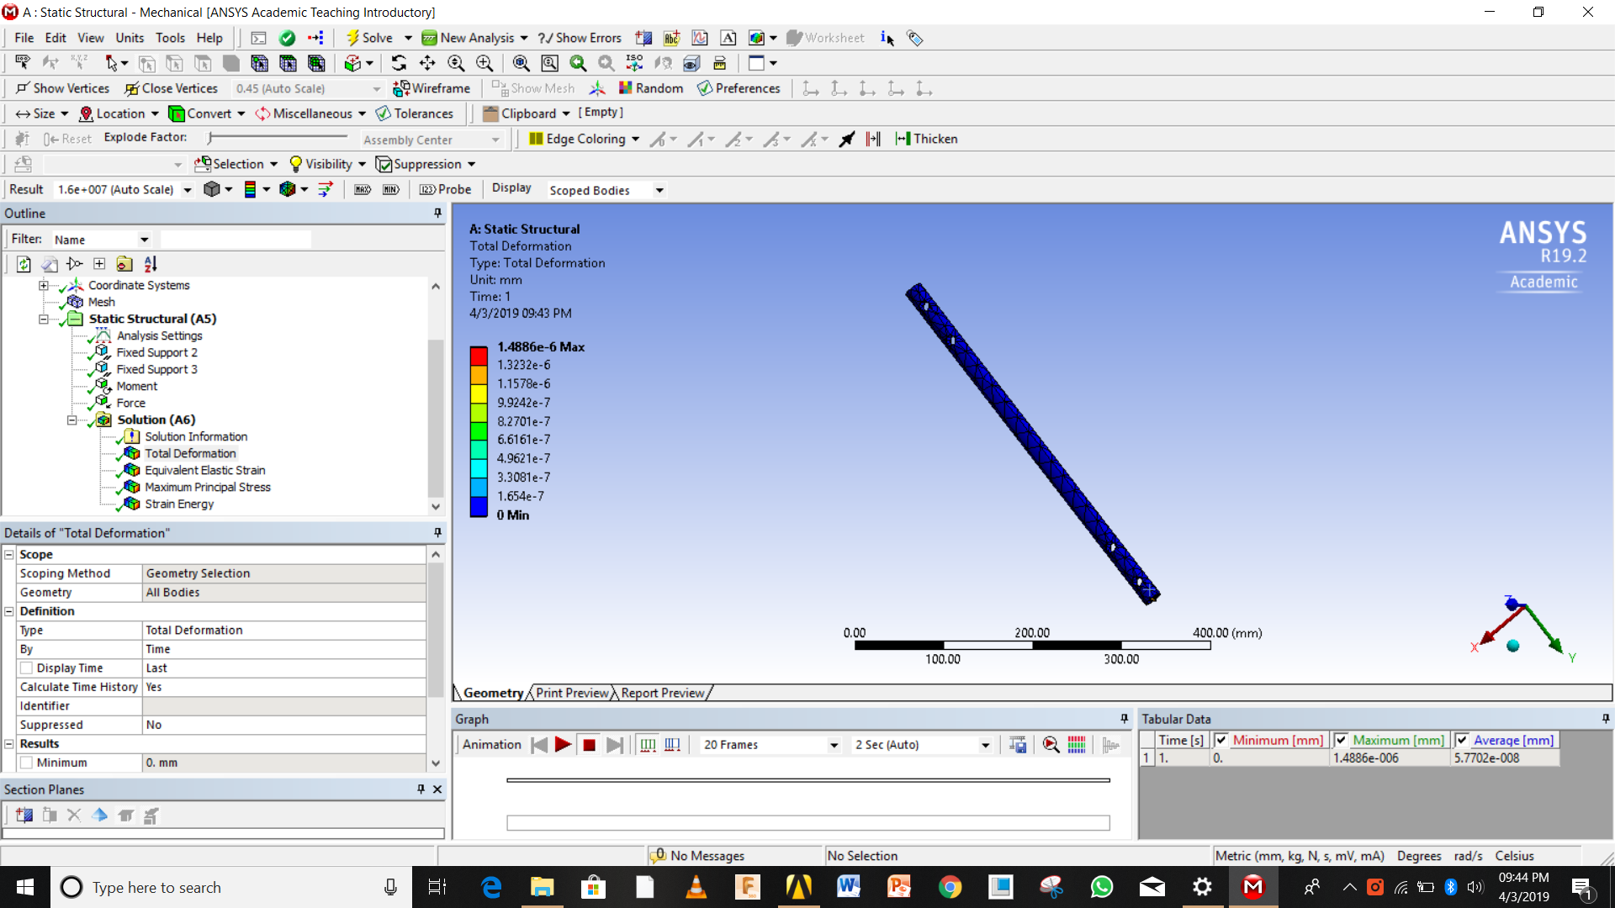

Figure 7.2 : Total deformation of shaft

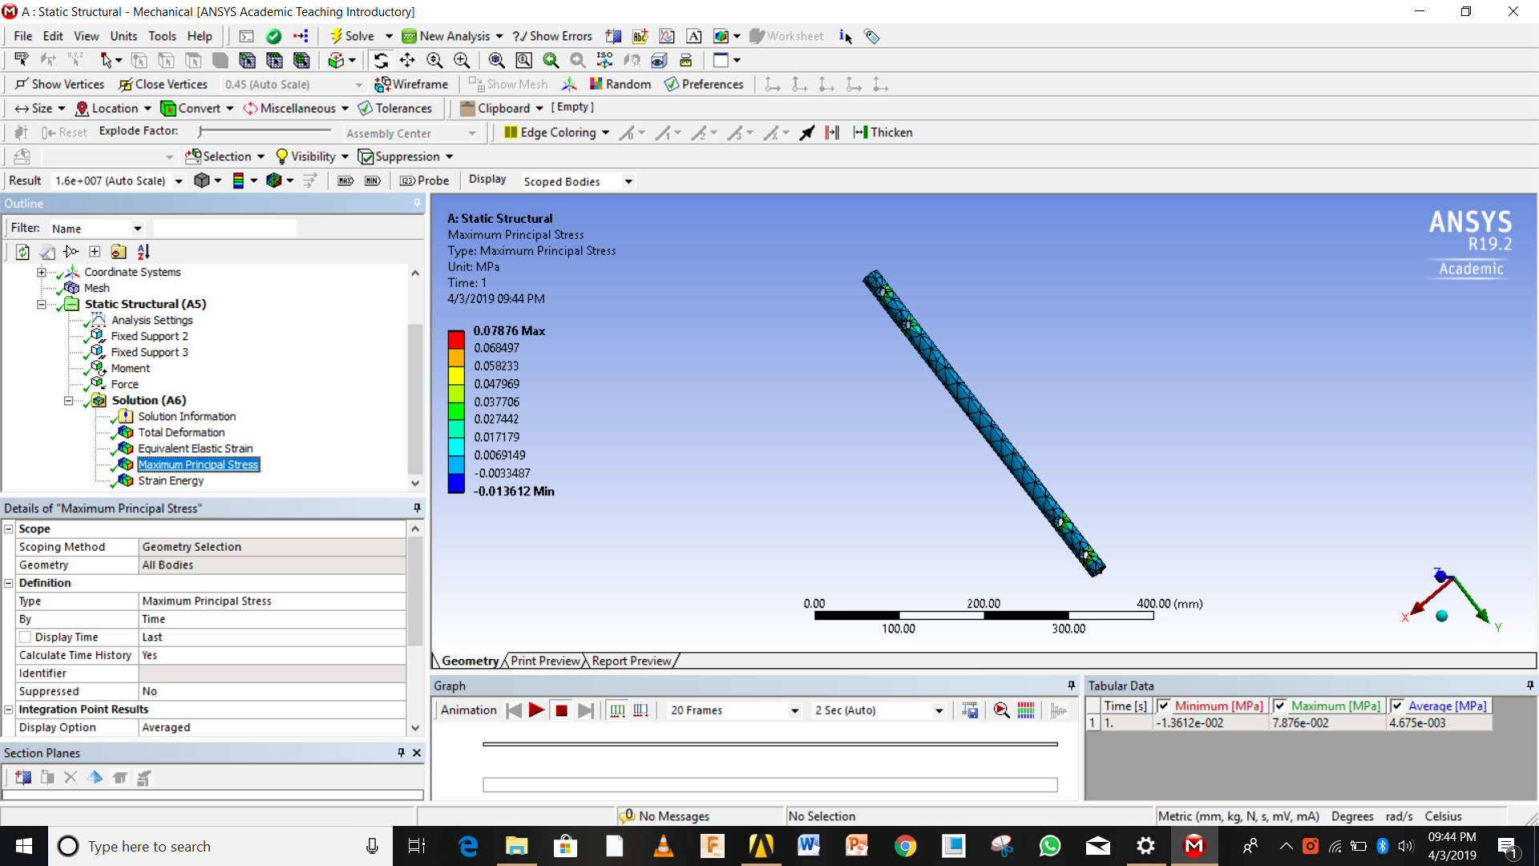

Figure 7.3 : Total principal stress

**Chapter 8**

**TO DESIGN BEARING**

**8.1 To calculate the axial and radial forces-**

Total compressive or lift force= (Fl )Savonius+ (Fl)darrieus=35.69+ 870.86 N=906.55N

Total Bending Force will be the net effect of centrifugal force and Drag force of all 3 element Fb=71.25 N+873.76 N-42.7671N+13.511N+0.5869 N= 916.34N

Here the lift force will act as the axial force so axial force will be 906.55 N.Here the radial force will be due to the drag force on the shaft which is 916.34N.

As we know we have selected the size of shaft to be 20 mm and it is safe for design and hence we decided the size of the bearing which has the 20 mm inside diameter. According to Inner diameter we selected the bearing by trial andd error and its number is 6304 single row deep groove ball bearings

Fa=906.55 N

Fr=916.34 N

Expected life 30000 hr

n=60 RPM

d=20mm

Fa/Fr=0.9893

For Fa/Fr=0.9893 the value of X=1; Y=0

P=X*Fr=916.34 N

Life(L10)=60*n*life in hour/106

= 108 Million Revolutions

C=P* L10 0.334

=4363.79 N

From catalogue of 6304 bearing we compare the value with given C 13500 , and we found it to be less. And hence it will work for our desired life with efficiency.

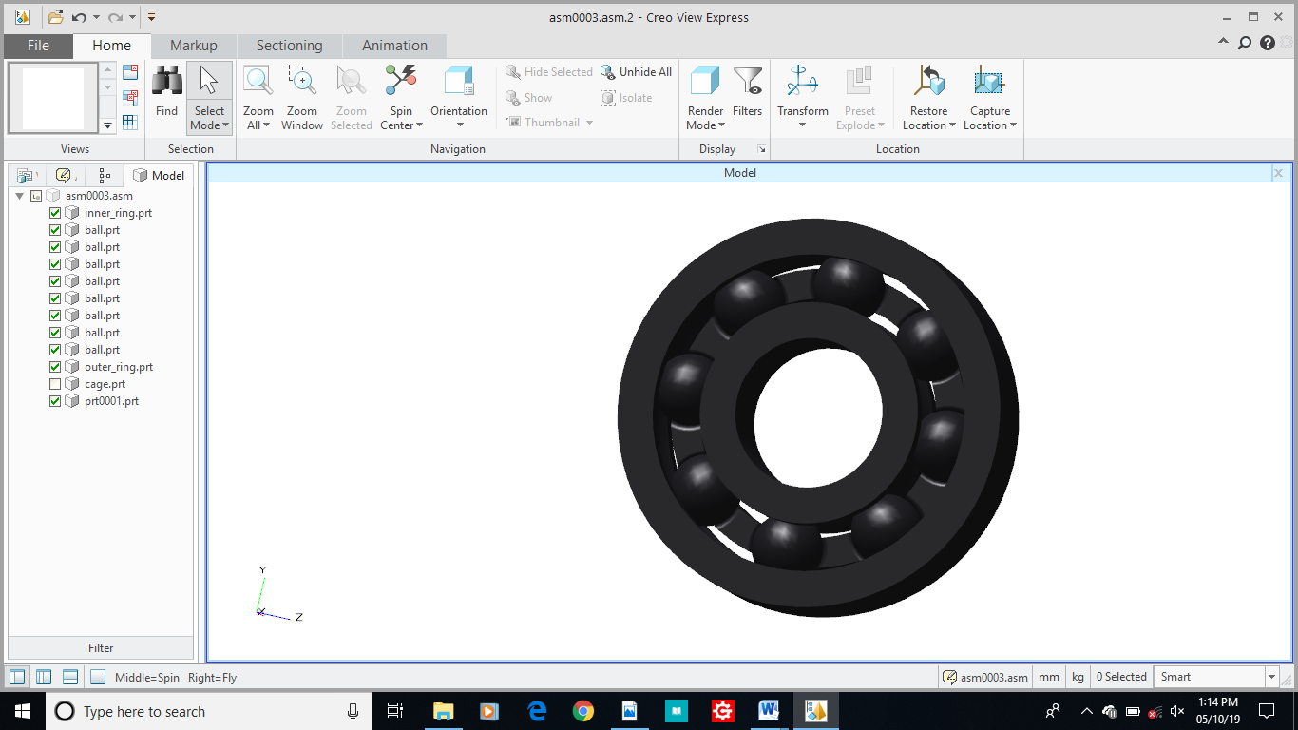

Figure 8.1 : Bearing 6304

Chapter 9

**ASSEMBLY OF SAVONIUS AND DARRIEUS TURBINE**

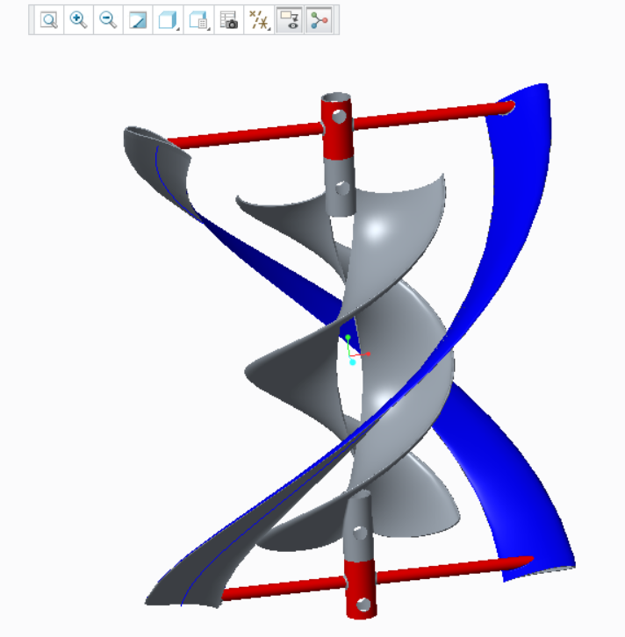**9.1Combined view of the Savonius and darrieus turbine-**

Figure 9.1:Assembly and its Geometric model

**9.2 Detailing of Assembly-**

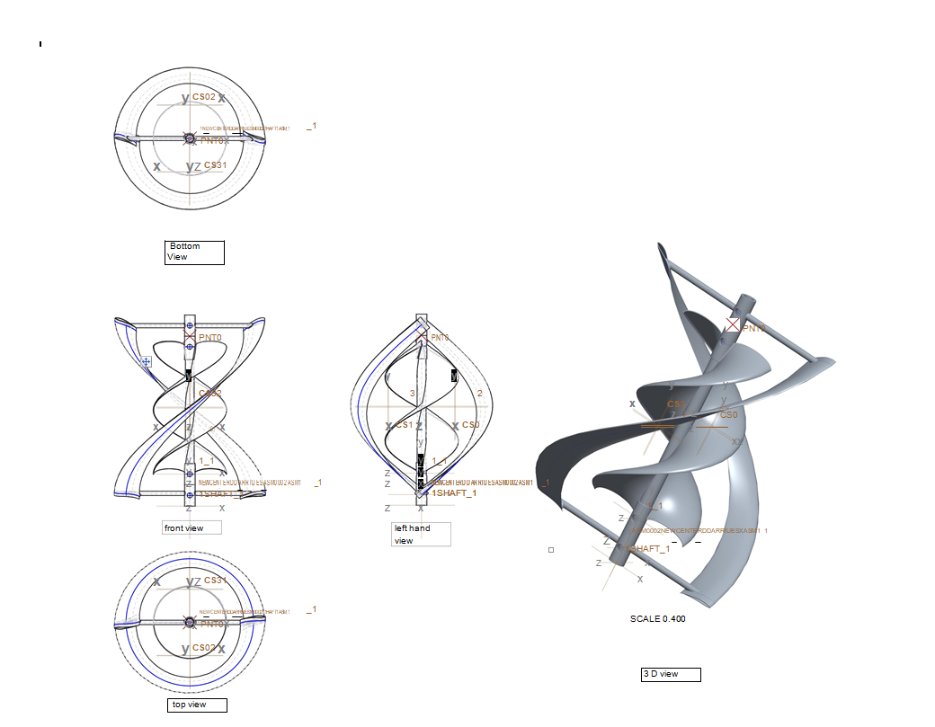

Figure 9.2: Assembly and its geometric model detailing

**9.3 FDM printed model of assembly-**

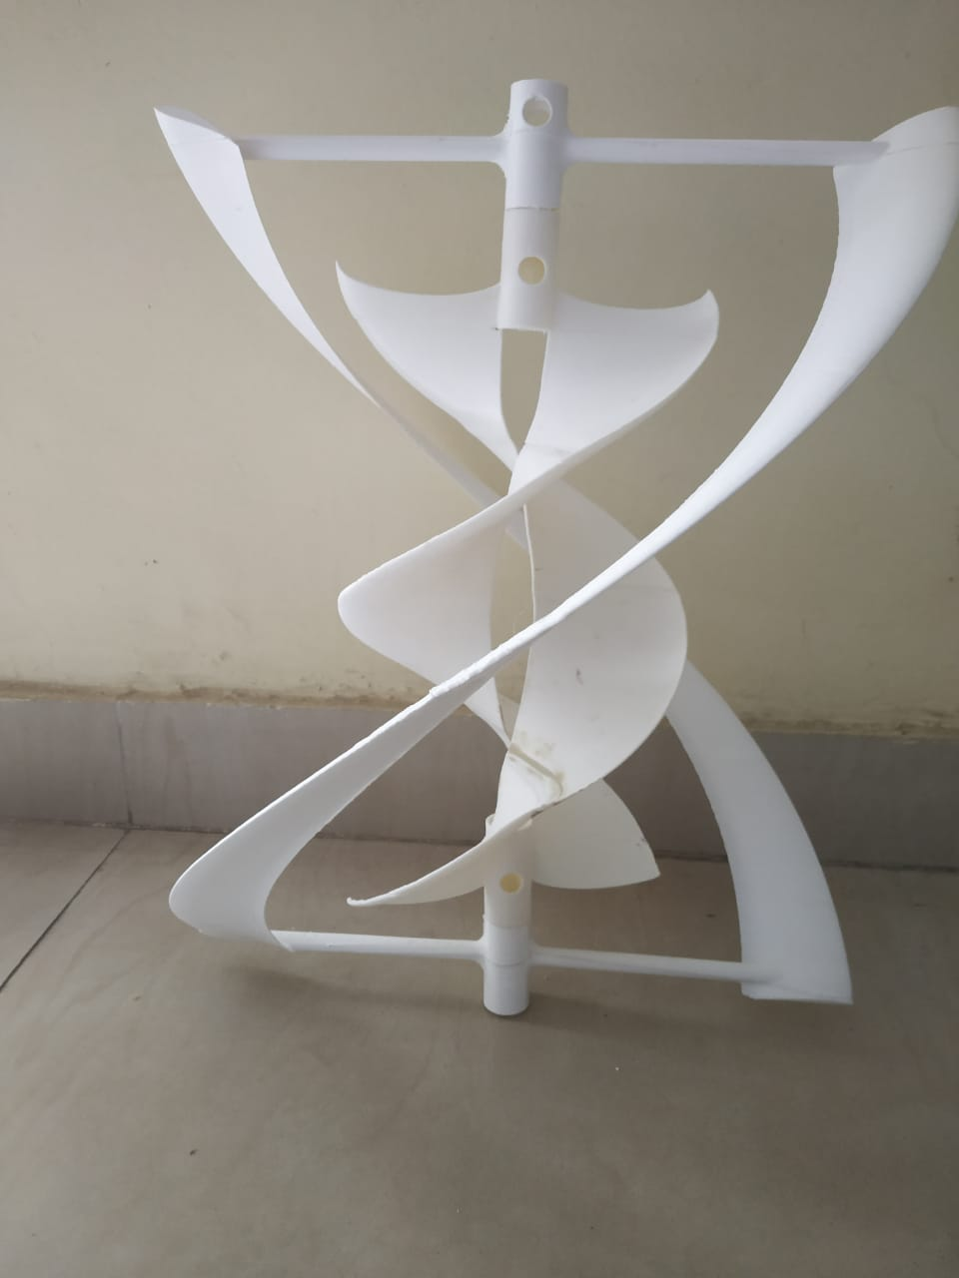

Figure 9.3 : FDM printed Model

9.4 Full assembly with various component of VAWT

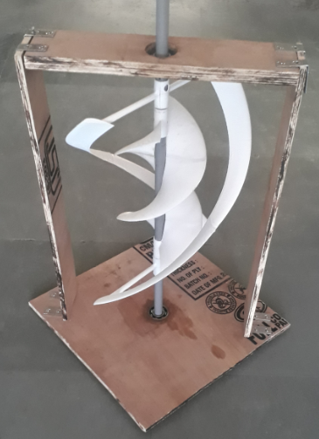

Figure 9.4 : Complete assembly of all components

**9.5 Bill of material**

Table 9.1 : Bill of Materials

|  |  |  |  |
| --- | --- | --- | --- |
| **Sr No** | **Name of part** | **Quantity** | **Total Price** |
| 1 | Darrieus | 1 | 5500 |
| 2 | Savonius | 1 | 3600 |
| 3 | Screw 0.5” | 24 | 30 |
| 4 | Stud 2” | 4 | 20 |
| 5 | Bearing 6304 | 1 | 330 |
| 6 | Plywood 600*600mm2 | 1 | 200 |
| 7 | L 1.25” | 8 | 160 |
| 8 | PVC pipe 1000 mm | 1 | 50 |
|  | total |  | 9890 INR |

Chapter 10

**RESULT AND DISCUSSION**

**10.1 Result of combining the Savonius and darrieus VAWT:**

When we installed Savonius and darrieus VAWT the effect was that savonius was moving at very high speed at around 300 RPM at 5 m/s and that of darrieus was moving at 87RPM and calculated coefficient of performance was find out to be 58 % and 55.5 % respectively. Due to combining both the VAWT the savonius helped the Darrieus Assembly was rotating at very small speed of air even at 2 m/s. and the RPM of assembly was find out to be 48 RPM. The efficiency of assembly find out to be 48 %. Which was greater than our expected value of 36% . By combing VAWTs and doing the static structural analysis we found that our design is safe at the 33.34Rad/s speed of rotation. At such speed the shaft deformation was found out be very less. At such speed the both individual turbines have sustained and hence our design is safe for each individual turbine.

**10.2 Effect on Coefficient of power :**

By using helical shape of wings and aero foil of S1210 the lift coefficient has been increased significantly and hence the torque also increased and which ultimately results in increase of the coefficient of power upto 39.9%. which is significantly same as expected coefficient of power. We used here the angle of attach to be 6 degree and the effect of that angle was positive on our design.

**10.3 Effect of using Helical shape of the wings for the Savonius and Darrieus VAWT:**

As studies have shown that straight blades have efficiency up to 22 % ;When we used the helical shape the lift coefficient has been increased which causes to increase the torque and increases the speed of rotation , at 5 M/s for savonius the speed was measured to be 300 RPM and that of darrieus measured to be 87 RPM and coefficient of power calculated was found to be 39% least.

**10.4 Effect of using the aero foil S1210**

By using the traditional NACA 2412 Aero foil the pressure difference was found to be 42 Pa, while that of using the S1210 aero foil the maximum pressure was found to be 1000Pa while that of list pressure was found to be 3100 Pa. More the pressure difference the more is the lift and drag forces on the aero foil which is ultimately get converted into the torque which produces positive power. Hence using the S1210 Aero foil has positive increase in airfoil.

# CONCLUSION

From result and discussion we have come to the following conclusion:

* We have successfully combined darrieus and savonius VAWT and it is operating under very low speed at 5m/s compared to its previous speed of 8 m/s .
* We have successfully analyzed and used the aero foil S1210 and we observed that the lift coefficient has been increased significantly.
* Our coefficient of power has been increased from 0.05 to 0.36.
* Helical shape increases the output power significantly.
* The whole effect of this design is that it is making the assembly self-start.
* Using deflectors and the concentrators the output parameters have been significantly increased.

**FUTURE SCOPE**

* Optimum dimensions for operation has to be find out by using trial and error method with help of mathematical and simulation study.
* Optimum dimensions of the deflectors can be find out which may increase the efficiency.
* Optimum angle of attack has to be find out foe S1210 can be find out and there study is yet to be publish
* Concentrators for the VAWT is not studied very well in any literature so it is can be optimize.
* The combination of savonius and darrieus VAWT and its output parameters yet to be studied.

# REFERENCES

1. Islam M, Fartaj A, Carriveau R. “*Analysis of the design parameters related to a fixed-pitch straight-bladed vertical axis wind turbine*”, Wind Eng 2008;32(5):491507.
2. Robert Whittlesey “*Vertical Axis Wind Turbines: Farm and Turbine Design*” Exponent, Los Angeles, CA, United States Email: [rwhittlesey@exponent.com](mailto:rwhittlesey@exponent.com)
3. Kirke B. “*Evaluation of self-starting vertical axis wind turbines for stand-alone applications, Ph.D. thesis*”, Queensland, Australia: Griffith University; 1998
4. M.C. Claessens , “*The Design and Testing of Airfoils for Application in Small Vertical Axis Wind Turbines*”November 9, 2006.
5. Basilevs Y, Korobenko A, Deng, Yan J, Kinzel M, Dabiri JO. “*Fluid-structure interaction modeling of vertical-axis wind turbines*”, J Appl Mech 2014;81 081006-1.
6. Shun S, Ahmed N. “*Rapid prototyping of aerodynamic research models*”. Appl Mech Mater 2012;217-219:2016–25
7. M. Raciti Castelli, E. Benini, “*Effect of blade inclination angle on a Darreius wind turbine*”, Journal of turbomachinery,2012
8. S. Li, Y. Li, “*Numerical study on the performance effects of solidity on the straight-bladed vertical axes wind turbine*”, Power and energy Engineering Conference, 2010.
9. Yanzhao Yang and Yanfeng Zhang , Zhiping Guo , Ho Jinyama , Qingan Li , “*Numerical Investigation of the Tip Vortex of a Straight-Bladed Vertical Axis Wind Turbine with Double-Blades energies*”, 27 October 2017 .
10. Yanzhao Yang and Yanfeng Zhang , Q.Song,Z.Guo, Q.Li ., “*Effect of Blade Pitch Angle on the Aerodynamic Characteristics of a Straight-bladed Vertical Axis Wind Turbine Based on Experiments and Simulations*” ,energies , 11 June 2018
11. P. Deglaire, S. Engblom, O. Ågren and H. Bernhoff, “*Analytical solutions for a single blade in vertical axis turbine motion in twodimensions*”, European Journal of Mechanics B/Fluids, 28 (2009) 506-520.
12. Howell, R.; Qin, N.; Edwards, J.; Durrani, N. “*Wind tunnel and numerical study of a small vertical axis wind turbine*”. Renew. Energy 2010, 35, 412–422
13. K. Bassett , R. Carriveau, S.-K.D. Ting “*3D printed wind turbines part 1: Design considerations and rapid manufacture potential”* ,Elsevier .
14. Javier Castillo “*Small-scale vertical axis wind turbine design*”, december 2011
15. M. AbdulAkbar n, V.Mustafa “*A new approach for optimization of Vertical Axis Wind Turbines*” , Elsevier Department of Civil Engineering, National Institute of Technology Calicut, NIT Campus (P.O), Calicut, Kerala 673601, India
16. S.S. Surprajha , K Vijayan , “*Design and analysis of Helical blade wind turbine*”, Vol. 5, IJIRSET , 5May 2016 , TN India
17. Arturo Reza, Guilibaldo Tolentino & Miguel Toledo, “*Construction of a helical vertical axis wind turbine for electricity supply*” 01 Sep 2015.; <https://doi.org/10.1080/16864360.2015.1077069>
18. S. zanforlin and Letizia, “*Improving the performance of wind turbine in urban environment by integrating the action of diffuder with the aerodynamics of roof top*”, vol. 82 december 2015;pages 774-781.
19. Magdi Ragheb1 and Adam M. Ragheb, “*Wind Turbines Theory - The Betz Equation and Optimal Rotor Tip Speed Ratio*” , 1Department of Nuclear, Plasma and Radiological Engineering ,Department of Aerospace Engineering University of Illinois at Urbana-Champaign, 216 Talbot Laboratory, USA.
20. Micha Prekumar T., Mohan T. Seralathan Siwamani, “*Design and Analysis of a Permanent Magnetic Bearing for Vertical Axis Small Wind Turbine*”, 1st International Conference on Power Engineering, Computing and control, PECCON-2017, 2-4 March 2017, VIT University, Chennai Campus.
21. Xin Jina,b,Yaming Wanga, Wenbin Jua, Jiao Hea, Shuangyi Xiea, “*Investigation into Parameter Influence of Upstream Deflector on Vertical Axis Wind Turbines Output Power via Three-dimensional CFD Simulation*” College of Mechanical Engineering, Chongqing University, Chongqing 40004, P. R. Chinab State Key Laboratory of Mechanical Transmission, Chongqing 400044, PR China.

Table A SKF bearing design parameters

